Topic 1.1 Businesses: Activity
Task 1 (AO1):
Answer the following short answer questions about businesses:
- What is the difference between the terms ‘Goods’ and ‘Service’?

- What is a supplier? What might a supplier provide to Nike ?

- What labour, machinery and raw materials will Nike need to produce trainers?

- What is the difference between a ‘Consumer’ and a ‘Customer’?

Task 2 (AO1-AO3):
In Barnet Shopping Centre there is a vacancy for a new restaurant in the food court. There are several restaurants in the food court including Subway, Burger King and KFC. Being able to own your business has been something Leon has desired for a long period of time. Leon has worked in the restaurant business for five years and specialises in Mexican cuisine. He has never previously owned a business. Here you need to provide some recommendations on what Leon must think about before starting up his own fast food restaurant business on each of the following categories.
Criteria | What must Leon consider?
Suppliers
Production
Competition
Customers

Task 3 (AO1-AO3):Read the following case study and then answer the questions underneath:
Case Study
The Jayne Varndall Motorcycle prepares motorcyclists for their riding tests. To ride a motorcycle, you need to have a specialist driving licence which is different from one for driving a car or a lorry.
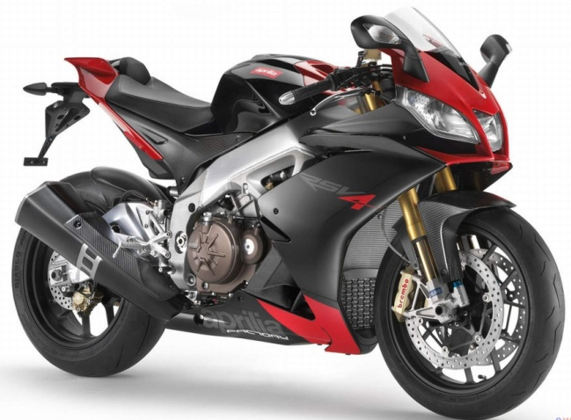
Jayne Varndall, the owner, employs four people: A secretary and administrator and three instructors. She has an office and a large car park that she uses to instruct motorcyclists at the start of their training. Her business has operated for the past six years. Jayne’s customer’s pay for basic instruction course in riding a bike. Then they are charged by the hour for on-road practice before taking their test at a local government centre. For their training, they can either hire a motorbike from her or bring their own bike.
The market for motorcycle instruction is competitive. There are three other businesses in the area that offer similar services. There used to be four, but one business closed down because it couldn’t get enough customers.

- What service does Jane’s business offer ? (1)

- ‘Jayne Varndall provides a service to her customers’. What is meant by a ‘service’ and ‘customers’ for Jayne Varndall’s business? (4)

- Explain how two physical resources are used by Jayne Varndall in her business (4)

- What staff does she employ?

- ‘One business closed down because it could not get enough customers’. Giving reasons for your answer analyse two possible reasons why Jayne Varndall’s business has managed to survive against the competition for six years. (4)

.

