Topic 1.4 Branding and Differentiation: Activity
- Sort out the following products into Generic Product, Brand or Own Brand:
Product: | Generic Product, Brand or Own Brand:
Apple iPad
Tesco Value Cards
Oil
Amazon Kindle
Gas
Tesco’s Finest Cereals

- Read the following Key Terms:
Key Term: | Definition:
Product Differentiation | Making one product different from another in some way, for instance through the quality of a product, its design, packaging or advertising.
Premium Price | A price which is above the average for products of a particular type.

- Look at the two products below:
Nike Football Boots | Patrick Football Boots
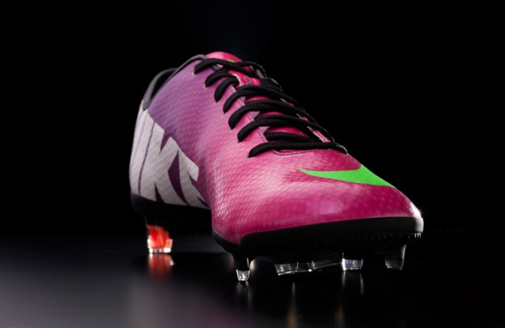 | 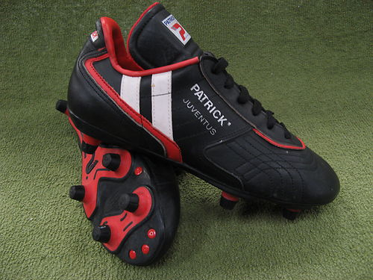
£49.99 | £15.99

- How can ‘Product Differentiation’ allow businesses to charge a ‘Premium Price’? Use the example above to justify your answer.
- How does branding affect ‘Repeat Purchase’ and ‘Product Trial’ for a business? Use a real life example to justify your answer.

- Creative Zen, a brand that creates headphones and is looking to create a brand new headphone to rival the Apple’s Beats by Dr Dre branded headphones. They have asked you to come up with FIVE ways in which they could have ‘Product Differentiation’ from the competition.
Strategy: | Reason:

- What are the benefits of branding?
Benefit of Branding: | Reason:

