Topic 1.6 Franchising: Starter Activity
Task 1:
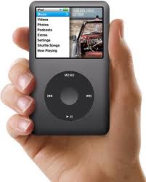
We are going to recap on the learning of ‘Added Value’ from last lesson. The image on the left hand side is of an iPod created by Apple the world’s current largest brand. For this task you need to come up with up to FIVE strategies on how Apple can add value to this product.

Number | Strategy to Add Value:
1
2
3
4
5

