Topic 2.2 Thinking Creatively: Activity
Task (AO1-AO3): You need to read the ‘Product’ information and use the different types of ‘Creative Thinking’ to explain how you would resolve these issues.
Product: | Creative Thinking:
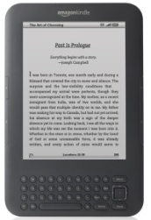  Amazon has found that the Kindle has been a very successful product but is now facing competition from other brands. Amazon is now thinking about how they can develop their product to maintain sales. | Blue Skies  Thinking
Samsung have developed an excellent reputation for the Smart Phones that they have produced. They have a high level of competition and are currently developing a new Smart Phone for their Galaxy series. They have asked you to use lateral thinking to come up with an improved product. | Lateral  Thinking
After several of Mars’s competitors in the chocolate market have expanded their product range, Mars has decided to create a new hazelnut version of its chocolate. They want you to create a new recipe through deliberate thinking. | Deliberate Creativity
Colgate has been using the same packaging for the last few years. They require you to develop new packaging for their toothpaste product. | Blue Skies  Thinking
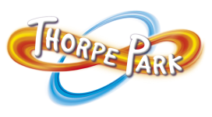  Thorpe Park wants to create a new rollercoaster for their theme park. They have asked you to use lateral thinking to come up with a new ride and justify why it is lateral thinking to develop the rollercoaster. | Lateral  Thinking
McDonalds are always looking to expand their product range. They have asked you to think of a new vegetarian product using deliberate thinking to come up with your product. | Deliberate Creativity

