JOB PRODUCTION

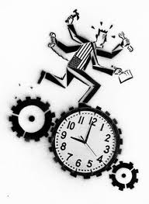
Each person in your group needs to make their own boxes:

Instructions for making box:
- Choose a piece of coloured card
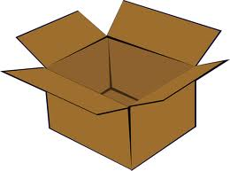
- Draw around the template on your card
- Cut out drawn template
- Fold flaps
- Glue box together
- Add logo (either black star, blue circle or red square)
Each person in your group needs to be allocated ONE of the following roles...

- Cutters X 2 (Cut out correct colour templates according to batch)
- Folder (Fold flaps)
- Gluers X 2 (Glue Box together)
- Logo Drawer (Draw correct logo onto the right coloured box)

Your group cannot start a new batch until the last order is complete, once your group have finished the last batch, start again and repeat as many as the batches as you can.

Batches: Produce 4 red boxes with a black star
Produce 4 green boxes with a blue circle
Produce 4 blue boxes with a red square
Each person in your group needs to be allocated ONE of the following roles...

- Cutters X2 (cut out box templates);
- Folder (score flaps)
- Gluers X 2 (glue box together)
- Logo Drawer (Draw correct logo in the right order).

Requirements: First box with Blue circle
Second box with Black star
Third box with Red square
Keep repeating the order above. You are to work in a production line to produce your boxes.
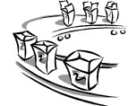
FLOW PRODUCTION
BATCH PRODUCTION

