Adding Value: Activity
Task 1 (AO1):
- Explain what it means by the term ‘Added Value’.
- Provide TWO examples of how a business can add value to a product.
- Explain what is meant by the term ‘Unique Selling Point’.
- Give ONE example of a business that has a unique selling point.
Task 2 (AO2-AO3):
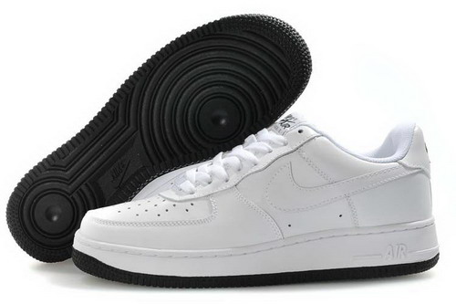
Nike Air Force One Trainers
- Explain FIVE factors that Nike have used on these trainers to add value to the product.
- Would you say that these trainers have a USP? If so give a reason why.
- Why is it important to add value to these trainers?

Music Track: Ed Sheeran - perfect
- Explain THREE factors that add value to this product.
- Would you say that this music track have a USP? If so give a reason why.
- Why is it important to add value to this music track?
Task 3 (AO3):
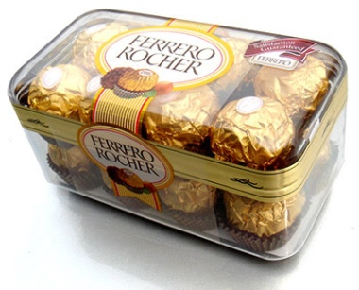
Ferrero Rocher is looking to bring out a new type of chocolate that they will sell to their customers in a variety of locations. The idea is that they want to expand their product range to their customers. This will be mint chocolate and Ferrero Rocher appreciate that there are a lot of competitors that sell mint chocolate such as After Eights, Kit Kat Mint and Munchies Mint.
- They have asked you to come up with FIVE clear strategies that they can use to add value to the product. For each strategy you must explain why this will add to the value of the product.
- Once you have completed this you must explain why it is important to Ferrero Rocher that they add value to their products.

