Bowman’s Clock
Meet the authors
Cliff Bowman is Professor of Strategic Management, Cranfield University. Professor Bowman undertakes a wide range of consulting assignments and has published over 60 papers. He was the Academic Dean of the School of Management from 1998–2006. Previously in his career, he was an economist working for the Civil Aviation Authority.
David Faulkner is Emeritus Professor of Strategy at Royal Holloway, University of London. Educated at Oxford, he was until 2003 a Fellow at Christ Church, Oxford and a member of the Governing Body. Earlier in his career he was the Deputy Director of the Oxford University Said Business School. In 1989 he was appointed as a lecturer at Cranfield School of Management, where he worked alongside Cliff Bowman.
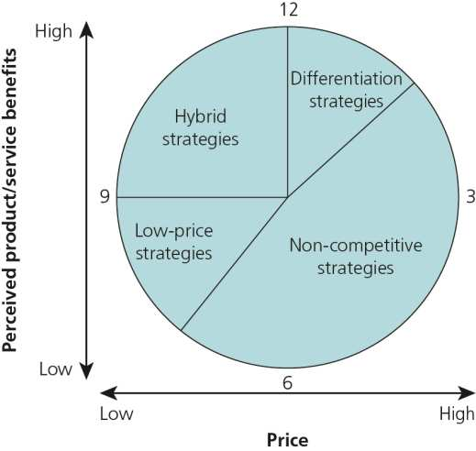
One of the advantages for a customer in a competitive market is that they have choices. Therefore, a firm must compete effectively with its competitors and find a unique competitive advantage over them.
Bowman’s clock is a model which helps a firm design a competitive marketing strategy to enable it to compete and survive in a highly competitive market. The model, designed by Bowman and Faulkner in the 1990’s, was based on Michael Porter’s generic strategies model.
The model allows businesses to explore eight alternative strategies in an effort to determine what they offer to customers. These include:
- Low price/low added value – business offers the lowest price possible – bargain basement – quality is often poor and there is little customer loyalty.
- Low Price – business offers low prices and relies on high volumes of sales.
- Hybrid – business tries to strike a balance between a reasonable price and reasonable quality that’s perceived as better than their competitors.
- Differentiation – business offers products with USPs, this could be unique product features or branding.
- Focused differentiation – business offers differentiated products aimed at a niche market, they are able to charge high prices for them though sales volumes might be low.
- Increased price/standard – business raises its prices with no equivalent improvement in quality (not a long-term option in a competitive market).
- Increased price/low value – business operates in a monopoly or oligopoly so can charge high prices for a low value product. Regulation and competition mean this can’t last for long.
- Low value/low standard price – business offers low standard products for their standard price. This can’t last for long as customers feel cheated.
Businesses can then compare their strategies to those of their competitors. Managers will need to analyse their competitive advantage in order to have a more informed view of which strategic direction to take. If they decide to compete on price, they will need to analyse their competitive position in terms of pricing. However, if they decide to compete on perceived value, they will need to analyse their market to ensure that they understand the market’s core values and the perceived value of the competition by the target customer base.

