Break Even
Study the information below and then answer the questions that follow.
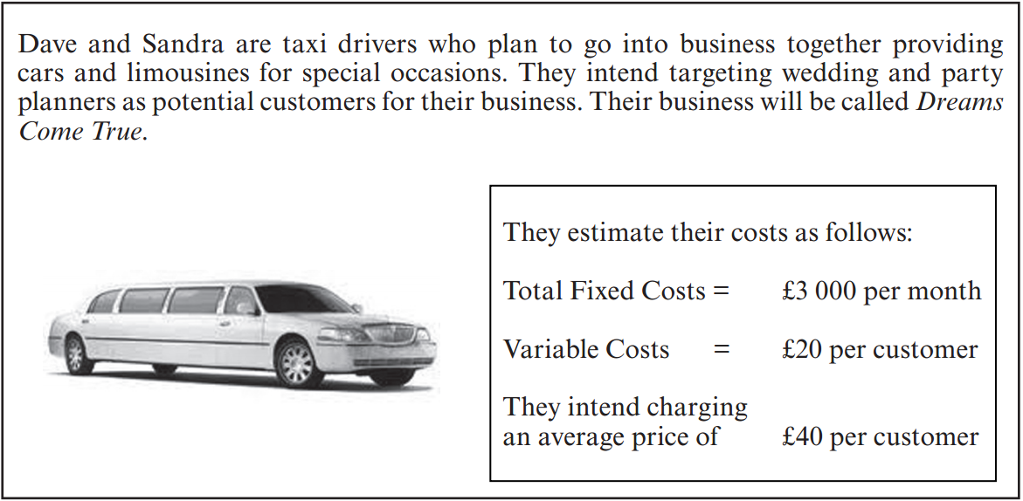

Using the formula below and the information given in the scenario, insert the correct amounts in the shaded areas.

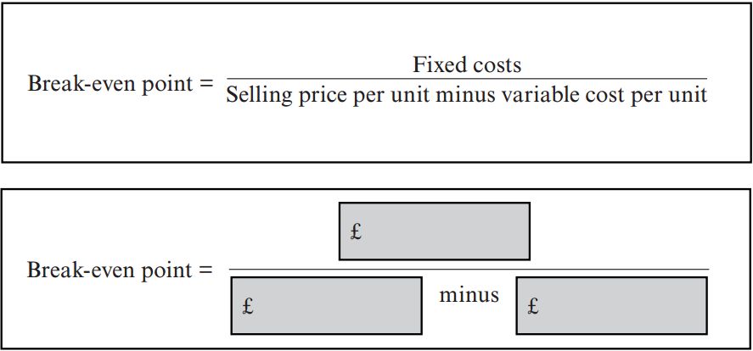

QUESTION TIME!

Calculate the number of customers Dreams Come True must have to break even.

Use the scenario from task three to complete the output table.
Customers per month | Fixed Costs (£) | Variable Costs (£) | Total Costs  (£) | Total Revenue  (£)
0
50
100
150
200

QUESTION TIME!

What would be the profit or loss is the business had 100 customers a month?

Plot a break even chart for Dave and Sandra then label it

Study the information below and then answer the questions that follow.

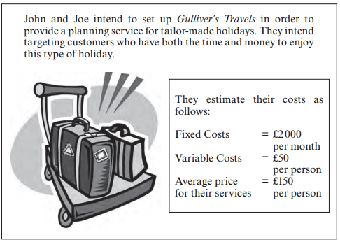

Use the scenario above to complete the output table
Customers per month | Fixed Costs  (£) | Variable Costs (£) | Total Costs  (£) | Total Revenue  (£)
0
10
20
30
40

Plot a break even chart for John and Joe then label it

QUESTION TIME!

State the number of customers Gulliver’s Travels must have to break even

A grade exam questions:
State the profit or loss the business would make in a month if it had 30 customers.
State one course of action John and Joe could take if there was an unexpected increase in costs.
Explain the impact of your chosen course of action on Gulliver’s Travels.
What are the limitations of a break-even analysis?

