Command words

Analyse
Separate information into components and identify their characteristics.

Example question:
A small business that competes in a market where demand is price elastic is introducing a system of quality assurance. Analyse how quality assurance might improve its competitiveness. (Specimen A Level Paper 1 Q19)

Example (full marks) answer:
Quality assurance may lead to fewer errors in the productive process or service which could lower costs and enable price to be lowered – important in a price competitive market. A better quality of product or service may retain more customers even though rival firms are lowering their price to attract them.
A small business will be unlikely to benefit from economies of scale from which to compete on price so quality may be important to keep and attract customers.

This answer would be marked on a Levels Mark Scheme and to earn the full 9 marks, students would have to develop a good understanding of the demands of the question, showing sound knowledge and understanding of business concepts and principles and ability to analyse these in the context of the question.

Guidance
In order to analyse the impact of quality assurance, it helps to explain the meaning of ‘a market where demand is price elastic’ and explain what ‘a system of quality assurance’ means.

Calculate
Work out the value of something.

Example question:
Based on the data in Table 2, calculate the contribution per unit. Show your workings. (Specimen A Level Paper 1 Q16.2)

Example (full marks) answer:
Number of units = Total revenue / Selling price = £22 500 / £7.50 = 3 000 units
Contribution per unit = Total contribution / Number of units £15 900 / 3 000 = £5.30

Guidance
A correct final answer, to the required degree of accuracy and with the correct units, will score the full 4 marks here.

Describe
Set out characteristics.

Example question:
Describe the trend in sales of luxury goods in China as shown in the data shown in Figure 1. (Specimen AL Paper 2 Q01.1)

Example (full marks) answer:
Some characteristics of the trend include: sales growth is always positive or sales are always rising, the particular peaks or troughs in the rate of growth.

Guidance
Three characteristics of sales growth are required for the full 3 marks, usually possible in short simple sentences.

Evaluate
Judge from available evidence.

Example question:
From 2011 to 2013, Sainsbury’s gearing rose from 35.9% to 40.1% and its current ratio increased from 0.55 to 0.61. Evaluate the possible implications of these changes for Sainsbury’s during a period of “difficult market conditions” (line 73) and low interest rates. (Specimen A Level Paper 3 Q03)

Example of a key point in the answer:
Although rising, gearing is still relatively low being below 50%. During difficult market conditions when profits may be low, having lower gearing carries less risk as there may be lower commitment to high fixed repayments on borrowing.
However interest rates are low which lowers the cost of borrowing to finance large-scale investment projects.
Evaluation may require a weighing up of different implications like those above to give an overall judgement.

This answer would be marked on a Levels Mark Scheme and to earn the full 16 marks, it would have to contain sound, focused analysis and well-supported evaluation. There would need to be good application of relevant business principles and clear, logical chains of reasoning, supported by good use of the data provided.

Guidance
In order to evaluate the implications, counter arguments and consideration of circumstances need to be considered. These points must be analysed and evaluated in order to reach a final judgement on the question from the available evidence at the end.

Explain
Set out purposes or reasons.

Example question:
Explain the factors that might influence the price at which Morgan sells its cars. (Specimen A Level Paper 2 Q02.1)

Example of a key point in the answer:
One factor is the price of cars made by competitor rivals to Morgan. The answer could be developed to outline the impact of the pricing of a substitute car.

This answer would be marked on a Levels Mark Scheme and to earn the full 6 marks, the student would have to develop a selection of the key issues relevant to the question, with sound knowledge and understanding of business terminology, concepts and principles.

Guidance
The factor is stated clearly and then developed to address the question posed. Relevant business concepts are incorporated.

Justify
Support a case with evidence.

Example question:
Under Justin King, Sainsbury’s changed its strategy. Do you think that to be successful the strategy of a business needs to be determined mainly by what is happening in its external environment? Justify your answer. (Specimen A Level Paper 3 Q06)

Example of a key point in the answer:
What is happening in the external environment is important as it creates Opportunities and Threats which will influence strategy. These may be considered using PEST, Porter or other models. However, strategy also may need to be linked to the internal environment eg it will be affected by finances, expertise of staff and vision of the managers etc.
Justification will argue which, if any, is the more important determinant of strategy.

This answer would be marked on a Levels Mark Scheme and to earn the full 24 marks, it would have to contain sound, focused analysis and well-supported evaluation. There would need to be good application of relevant business principles and clear, logical chains of reasoning, supported by good use of the data provided

Guidance
To justify a recommendation, view or conclusion, key points must be presented in favour but their weaknesses and the case against should be considered as well. These points must be analysed and evaluated in order to reach a supported judgement on the question from the available evidence at the end.

To what extent
By how much or by how many.

Example question:
To what extent do you think the performance of Nissan’s workforce has been the main factor influencing its decision to increase car production at the Sunderland factory in the UK?
(Specimen AS Paper 1 Q15.2)

Example (full marks) answer:
The data provides some factors which relate to employee performance and from which arguments can be constructed for this as the main factor eg productivity, employee-employer relations etc. These factors should be set against others outside of workforce performance eg leadership, exchange rate etc to come to an overall judgement.

Guidance
A good response must make a supported judgement on the extent to which the performance of the workforce has been the main factor influencing Nissan’s decision. This involves a judgment of the significance of the workforce relative to other factors.

Question Structures

If you have a 3, 4, 5 or 6 mark question that asks you to explain or analyse a particular concept, you need to:

- Make a point or state an answer and explain the theory in the question (AO1)
- Apply with evidence to the case study or use an example OR expand on your first point (AO2)
- Explain/analyse your answer (AO3)

You would then repeat this structure based on how many points the question asks for.

For example:

Analyse one benefit and one problem of using JIT stock management. (6 marks)

- JIT stock management is a concept that means ordering stock only as and when it is needed
- A benefit of using this particular method is that it reduces costs
- This is because a business won’t have to spend money on storing stock that is not being used. This is because the supplier will have it until it is ordered

- A problem of using JIT is that a business cannot benefit from economies of scale
- Economies of scale can be seen in the format of bulk-buying
- If a business uses JIT stock management, it means they will only buy and order stock when it is needed, meaning that any bulk-buying discounts will be lost, meaning a business will usually pay full price every time it orders rather than any reduced rate

Now try the following questions:

Analyse two advantages that a restaurant might gain from setting marketing objectives. (6 marks)
Explain how interest rates might affect consumer spending. (4 marks)
Analyse one disadvantage of market mapping. (5 marks)
Distinguish between labour-intensive production and capital-intensive production. (4 marks)

A 9 mark question is different. Although it is similar to a 6 mark question, it will usually ask you to analyse 2 different points and these could both be advantages or disadvantages or a mixture of both. It will also usually ask you to refer to a case study text so be ready to analyse and apply your knowledge.

- Make your first point/state your theory (AO1)
- Find and quote evidence from the case study if applicable (AO2)
- Analyse your answer in context to the evidence, explaining the impact it will have on the business (AO3)
- Repeat this for the second paragraph, dependent on the question

For example:

Analyse two possible economies of scale that might occur in a national newspaper publisher. (9 marks)

- Economies of scale are when a business benefits from its size, where generally, the bigger the business is, the cheaper unit costs become. There are different types of economies of scale, one of them being technological economies of scale. This is where modern equipment can improve efficiency and lower costs.
- The case study states that ‘large firms gained from technological economies of scale…the need for high technology and cost effectiveness means that individuals with bright ideas were excluded from the market.’
- This therefore demonstrates that larger publishers with access to larger funds and therefore more advanced equipment gain an advantage over smaller firms who cannot compete for them on cost grounds because they don’t have equipment that will allow them to lower their unit costs and therefore maximise profit or pass these savings onto the customers and become more competitive – and therefore gain more sales.
- Repeat for second paragraph.

Now try the following question:

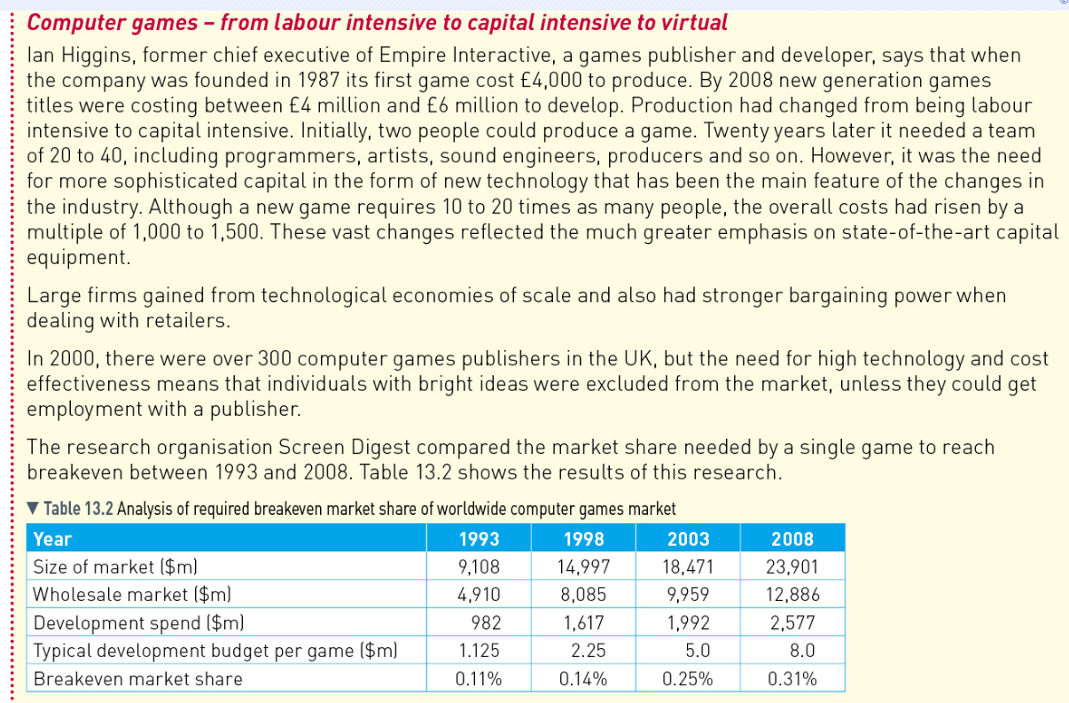

Analyse two reasons why it will be easier for small businesses to compete with larger firms in the market for games played on smartphones and tablets. (9 marks)

A 16 mark question and a 20 mark question are quite similar to each other, with a 20 mark question requiring more analysis and evaluation.

Both if these questions will usually ask you to decide on the best option between two arguments and come to a decision on which one is best.

The structure is as follows:

- Make your first point/state your theory (AO1)
- Find and quote evidence from the case study if applicable (AO2)
- Analyse your answer in context to the evidence, explaining the impact it will have on the business (AO3)
- Repeat this for the second paragraph, dependent on the question

You will notice that this is similar to a 9 mark question. However, to give yourself more chance of maximising your marks, you can use more evidence and further analysis.

- Make your first point/state your theory (AO1)
- Find and quote evidence from the case study if applicable (AO2)
- Analyse your answer in context to the evidence, explaining the impact it will have on the business (AO3)
- Refer back to the case study for more evidence and potential impacts of your points (AO2)
- Analyse this new evidence in further detail (AO3)
- Repeat this for the second paragraph, dependent on the question

You will then need to come to a decision on which of the 2 options is best.

- Considering (enter point) is an important issue facing the business (AO2/AO4 – Here you identify one of the key themes running through the case study. You then choose which of your options is the best argument considering this theme. This demonstrates that you are making a decision based on available evidence.)
- I believe (state most valid point from above 2 paragraphs) is the best option/argument
- Explain why you have not chosen your other argument (AO4) – Here you are stating the main disadvantage with the option you haven’t chosen
- However, to what extent my decision is valid, depends upon (explain the main problem or issue associated with your chosen option) (AO3/AO4)

Using the same case study above, please answer the following question:

To what extent was it inevitable that firms providing games for consoles, such as the Xbox or Playstation, would change from being labour intensive to capital intensive? (16 marks)

