Cash flow forecasts

1.
a)

b)

2.
(AO1) One way in which the cash position would change is that they would receive more cash inflows.
(AO2) A 50% off sale would attract more customers.
(AO3) This would lead to more cash flowing into the business.

Another way it could potentially affect the cash position is .........................................................
........................................................................................................................................................

This is because ...............................................................................................................................

........................................................................................................................................................

The impact of this would be ..........................................................................................................

........................................................................................................................................................

3.
........................................................................................................................................................

........................................................................................................................................................

........................................................................................................................................................

........................................................................................................................................................

........................................................................................................................................................
Extension:

Business revenues, costs and profits

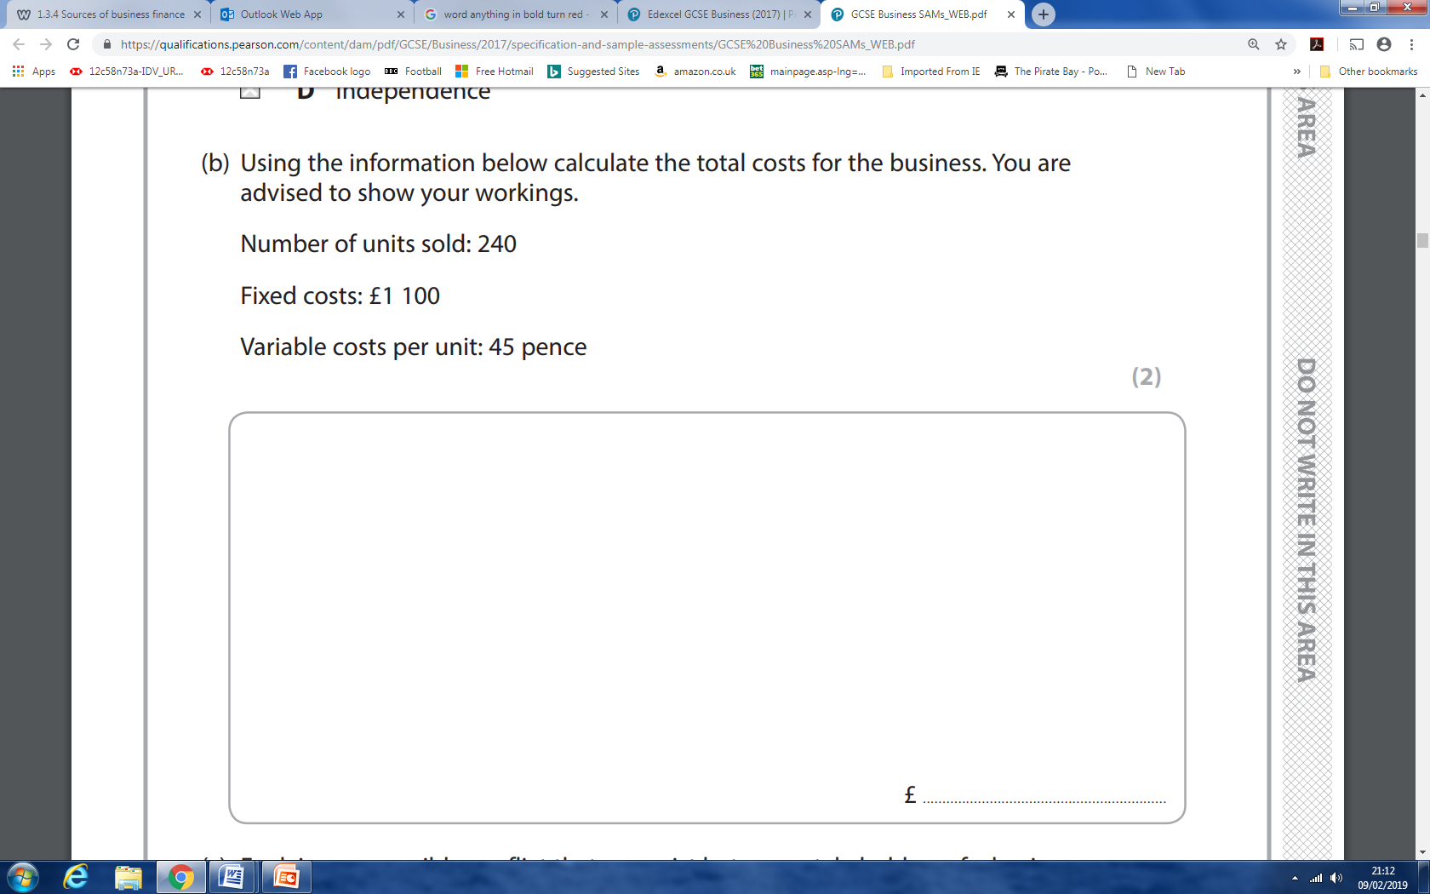

Option 1: They should increase average prices by 10%.
The case study states that .......................................................................................................................................
.................................................................................................................................................................................
This is important because .......................................................................................................................................
.................................................................................................................................................................................
.................................................................................................................................................................................
The impact of this would be ....................................................................................................................................
.................................................................................................................................................................................
.................................................................................................................................................................................
However, .................................................................................................................................................................
.................................................................................................................................................................................
.................................................................................................................................................................................
Option 2: They should reduce the cost of ingredients by using a cheaper supplier.
The case study states that .......................................................................................................................................
.................................................................................................................................................................................
This is important because .......................................................................................................................................
.................................................................................................................................................................................
.................................................................................................................................................................................
The impact of this would be ....................................................................................................................................
.................................................................................................................................................................................
.................................................................................................................................................................................
However, .................................................................................................................................................................
.................................................................................................................................................................................
.................................................................................................................................................................................
Considering .............................................................................................................................................................
I believe the best option is .....................................................................................................................................
It’s better because ..................................................................................................................................................
However, to what extent this decision is valid depends upon .............................................................................
.................................................................................................................................................................................

