Cheat sheet: Theories of motivation: Taylor, Maslow and Herzberg, Mayo
Meet the theorists…
Frederick Winslow Taylor
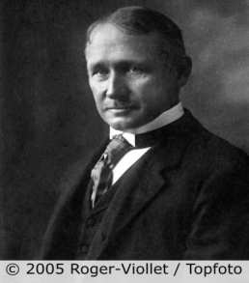
Frederick Winslow Taylor was considered to be the founder of Scientific Management. In 1911 he published his work in The Principles of Scientific Management. He was born in 1856 in Philadelphia in the United States. Although he passed the entrance examination for Harvard, he was forced to decline the place due to his failing eyesight not allowing him to complete night study. He took up an unskilled job as a patternmaker in 1875 and then became a machine shop labourer. His eyesight improved and allowed him to read for an engineering degree. Eventually, he became the chief engineer at Midvale Steel Works. He introduced time study at Midvale in 1883 before leaving and becoming an engineering consultant for various firms.

Abraham Maslow
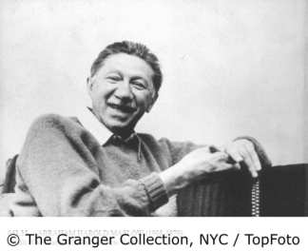
Abraham Maslow was born in 1908 in Brooklyn, New York. He was born to Jewish parents who had emigrated from Russia. He was educated at City College in New York, studying for a Law degree. Later, he moved to the University of Wisconsin, taking a bachelor’s, master’s degree and a doctorate in Psychology. He began his academic career at Brooklyn College, lecturing in the Psychology faculty. His most famous research is his hierarchy of needs.

Frederick Herzberg
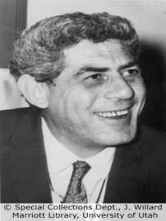
Frederick Herzberg was born in Massachusetts in the United States in 1923. He was educated as an undergraduate at the City College of New York before moving to the University of Pittsburgh to complete his master’s degree and doctorate. He continued his academic career at the University of Utah’s College of Business, where he became Professor of Management. He published his two-factor theory related to hygiene factors and motivators in 1959, refining this several times in subsequent years.

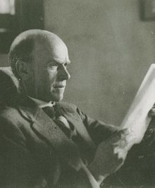
Elton Mayo
George Elton Mayo (26 December 1880 – 7 September 1949) was an Australian born psychologist, industrial researcher, and organizational theorist. Mayo was formally trained at the University of Adelaide, acquiring a Bachelor of Arts Degree graduating with First Class Honours, majoring in philosophy and psychology, and was later awarded an honorary Master of Arts Degree from the University of Queensland (UQ).

Taylor: Scientific management
Taylor was able to experience industry first hand as he gradually rose through the ranks within the steel industry. His theory of scientific management transformed the methods that firms adopted in their production processes. At the time of his writings, many production processes involved highly skilled men, who had completed their apprenticeships, undertaking the task of making the product. Taylor recognised the need to change this, introducing the concept of specialisation of task. This allowed for semi-skilled operatives, who were only trained to undertake one aspect of the transformation process, to input into the manufacture of products. In other words, scientific management removed the need for lengthy apprenticeships and introduced the concept of specialisation. Of course, high levels of employee specialisation will reduce the possibilities for job enrichment and has the potential to reduce employee motivation levels. Taylor became interested in the notion of increasing employee productivity, introducing the idea of ‘work study’ and ‘time and motion study’. This involved producing standard measures of productivity for set tasks that local managers could compare their staff with. Pay structures could then be designed to reward those workers who exceeded the standard expectation of productivity.

Maslow: Hierarchy of needs
Maslow introduced his Hierarchy of Needs in 1943. He conducted research into what motivated people to work. There are several versions of his theory, although the most common is based on a pyramid of five motivational needs. These are:
- Physiological needs – This is the basic need for food, water and shelter; the need to work to gain an income to pay for these basic items.
- Safety needs – This is the human need for security; the desire to live in a society where there is freedom from danger. This can be related to working in a safe environment where there is legislation, such as sickness pay and pension rights, which protect an individual’s remuneration.
- Social needs – This is the human need to feel accepted within a group – the sense of belonging. Work can provide individuals with this desire, such as the satisfaction of working within a team.
- Esteem needs – This is the need to be respected and have self-respect. In a working environment, promotion and status within an organisation can provide this.
- Self- actualisation – This is the highest level within the pyramid. It is the need for an individual to recognise their own true potential. Maslow believed that this final goal was endless and that individuals would enter a lifelong quest to discover it.
A worker is motivated to meet a particular need, starting at the bottom of the pyramid. Once the need has been satisfied they move up to the next level. Maslow argued that all workers were capable of moving through all levels.
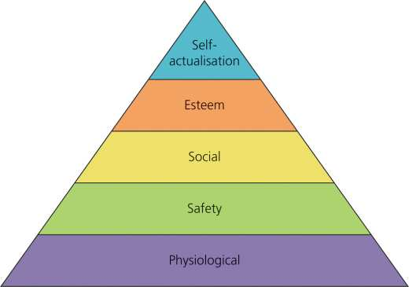

Herzberg: The motivators
Frederick Herzberg developed the two-factor theory of job satisfaction.Central to his theory were two sets of factors called, motivators and hygiene factors.The motivators were a group of factors that provide a worker with job satisfaction and will lead to motivation levels increasing. These tend to be intrinsic, which means that they are not materialistic, but relate to the job itself. The motivators include:
- A sense of achievement
- Recognition for effort and achievement
- Meaningful and interesting work
- Responsibility
- Opportunity for promotion
On the other hand, Herzberg’s hygiene factors tend to be extrinsic – not related to the work itself but materialistic factors that are related to it. These do not motivate the worker but a lack of them will lead to a fall in motivation levels. Examples include:
- Supervision
- Pay
- Working conditions
- Relationships with management
- Company policy and administration
Herzberg also discussed a concept called job enrichment. This is the process of providing workers with an opportunity to develop their abilities and skills at work by allowing them greater authority within the scope of their job.

Elton Mayo's contribution to management theory helped pave the way for modern human relations management methods.
Based on his well-known Hawthorne experiments, Mayo's management theories grew from his observations of employee productivity levels under varying environmental conditions. His experiments drew a number of conclusions about the real source of employee motivation, laying the groundwork for later approaches to team building and group dynamics. Mayo management theory states that employees are motivated far more by relational factors such as attention and camaraderie than by monetary rewards or environmental factors such as lighting, humidity, etc.
Elton Mayo developed a matrix which he used to illustrate the likelihood that a given team would be successful. His matrix demonstrates the role that varying combinations of group norms and group cohesiveness play in team effectiveness. The following are the four combinations of Mayo theory and the effect of each on team dynamics:
1. Groups with low norms and low cohesiveness are ineffective; they have no impact, since none of the members are motivated to excel, according to Mayo's theory.
2. Groups with low norms and high cohesiveness have a negative impact, since fellow members encourage negative behavior (e.g., gangs).
3. Groups with high norms and low cohesiveness have some degree of positive impact through individual member accomplishments.
4. Groups with high norms and high cohesiveness have the greatest positive impact, Mayo's theory predicts, since group members encourage one another to excel.

