Coffee shop in Leicester
The information below was taken from the website of the online training firm High Speed Training. (See the following page for a full screenshot of the website.) They are one of several firms that offer such online training for employees. Employees will often undertake the course in their own time but the course will be financed by their employer.
Samantha and George Wilkinson own a small coffee shop in Leicester. They employ three members of staff and require all staff to complete either a Level 1, 2 or 3 Food Hygiene certificate. The industry standard is for all employees to take at least a Level 2 Food Hygiene certificate.
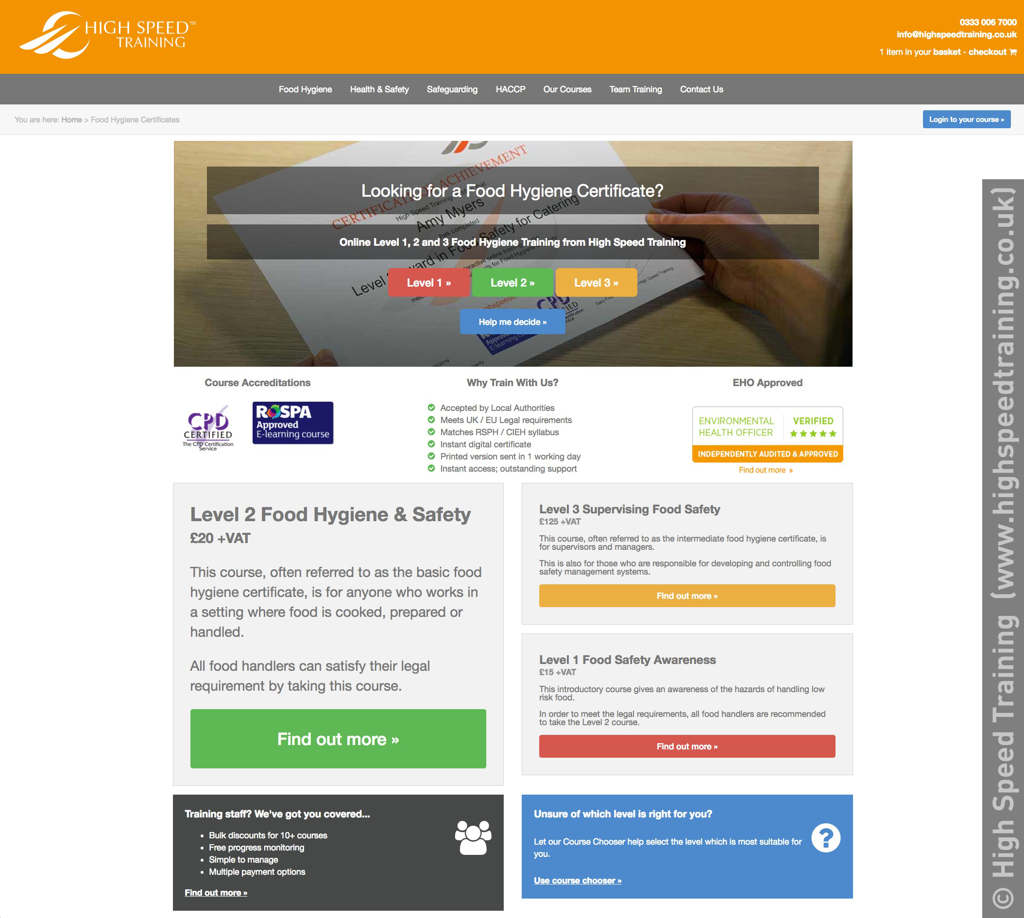

What are the benefits to the employer of this type of training? (6 marks)

What are the benefits to the employee of this type of training? (6 marks)

4. Is this type of training Formal or Informal?

5. One of their employees, Mary, is keen to develop her career in the Food and Hospitality industry. What might Mary do to develop her own career and how might Samantha and George support her too? (6 marks)

