How can falling levels of interest affect the levels of demand for a product? (6 marks)

………………………………………………………………………………………………………………………………………………………….………………………………
………………………………………………………………………………………………………………………………………………………………………………………….
………………………………………………………………………………………………………………………………………………………….………………………………
………………………………………………………………………………………………………………………………………………………………………………………….
………………………………………………………………………………………………………………………………………………………….………………………………
………………………………………………………………………………………………………………………………………………………………………………………….
………………………………………………………………………………………………………………………………………………………….………………………………
………………………………………………………………………………………………………………………………………………………………………………………….
………………………………………………………………………………………………………………………………………………………….………………………………
………………………………………………………………………………………………………………………………………………………………………………………….

Please write down the equation for Price Elasticity of Demand below:

Please calculate the PED for the questions below:

Price rises from £11 to £13
Demand falls from 76 units to 52 units.

Price falls from £110 to £99
Demand increases from 25,000 units to 31,000 units

Price rises from £4,500 to £4,700
Demand falls from 35,000 units to 34,500 units

A product has a PED of 2.6 and sells 5,000 products.
Next year price is expected to increase by 3.5%
Calculate the projected number of sales for next year:

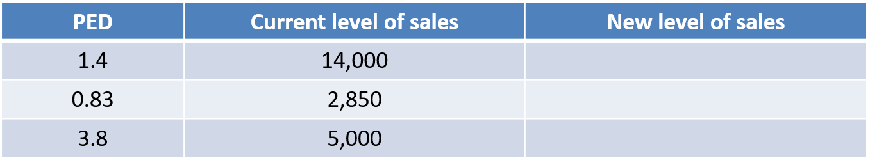

Next year, an increase in inflation means prices of most products are likely to rise by 2%. Please calculate the new levels of sales for the products above. You can use the space below to calculate your answers.

Below, create a mindmap of factors that will influence the price elasticity of demand of a product:

Why does the US government know that it can increase the price of cigarettes? (6 marks)

………………………………………………………………………………………………………………………………………………………….………………………………
………………………………………………………………………………………………………………………………………………………………………………………….
………………………………………………………………………………………………………………………………………………………….………………………………
………………………………………………………………………………………………………………………………………………………………………………………….
………………………………………………………………………………………………………………………………………………………….………………………………
………………………………………………………………………………………………………………………………………………………………………………………….
………………………………………………………………………………………………………………………………………………………….………………………………
………………………………………………………………………………………………………………………………………………………………………………………….
………………………………………………………………………………………………………………………………………………………….………………………………
………………………………………………………………………………………………………………………………………………………………………………………….

Extension:

Whilst it generates more income for the government, what potential problems could this cause? (6 marks)

………………………………………………………………………………………………………………………………………………………….………………………………
………………………………………………………………………………………………………………………………………………………………………………………….
………………………………………………………………………………………………………………………………………………………….………………………………
………………………………………………………………………………………………………………………………………………………………………………………….
………………………………………………………………………………………………………………………………………………………….………………………………
………………………………………………………………………………………………………………………………………………………………………………………….
………………………………………………………………………………………………………………………………………………………….………………………………
………………………………………………………………………………………………………………………………………………………………………………………….
………………………………………………………………………………………………………………………………………………………….………………………………
………………………………………………………………………………………………………………………………………………………………………………………….
………………………………………………………………………………………………………………………………………………………….………………………………
………………………………………………………………………………………………………………………………………………………………………………………….

Effect of price elasticity of demand on sales revenue and profit
Please read the information below carefully, there will be a question coming up that will require you to use this information.

- Inelastic demand – if demand for a good is inelastic, when its price rises the quantity demanded falls by a smaller percentage.
- This means that the impact of the price increase will outweigh the relatively small percentage change in demand, so sales revenue will increase
- As you are producing less, costs will be lower, so costs will fall as revenue increases
- A PRICE RISE WILL ALWAYS INCREASE SALES REVENUE AND PROFIT IF PRICE ELASTICITY OF DEMAND IS INELASTIC
- A PRICE FALL WILL LEAD TO LOWER SALES REVENUE AND PROFIT IF PRICE ELASTICITY OF DEMAND IS INELASTIC

- Elastic demand – if demand for a good is elastic, when its price rises the quantity demanded falls by a larger percentage.
- This means that the impact of the price increase will be outweighed by the relatively large percentage change in demand, so sales revenue will decrease
- this doesn’t necessarily mean a decrease in profit
- it will be cheaper to produce less goods so costs will fall as well as income
- if costs fall by more than income, profit will still be improved
- if costs fall by a smaller amount, profit will fall
- THUS, A PRICE RISE WILL ALWAYS DECREASE SALES REVENUE IF PRICE ELASTICITY OF DEMAND IS ELASTIC, BUT THE EFFECT ON PROFIT WILL DEPEND ON COST SAVINGS
- IN THE CASE OF A PRICE FALL, THE SALES REVENUE OF A GOOD WITH A PRICE ELASTIC DEMAND WILL ALWAYS INCREASE. HOWEVER, THE UANTITY DEMANDED RISES AND SO PRODUCTION COSTS WILL RISE. THEREFORE, IT IS IMPOSSIBLE TO PREDICT THE EFFECT ON PROFITS WITHOUT KNOWING THE COSTS OF PRODUCTION

- Unitary elasticity – if demand for a good is unitary, sales revenue will be the same whether price rises or falls
- A price rise would then be advisable if the business is aiming to increase profit, because this means a lower volume of sales would be required, which would enable production costs to fall
- However, the business may not increase price if it has other aims, such as increasing market share

