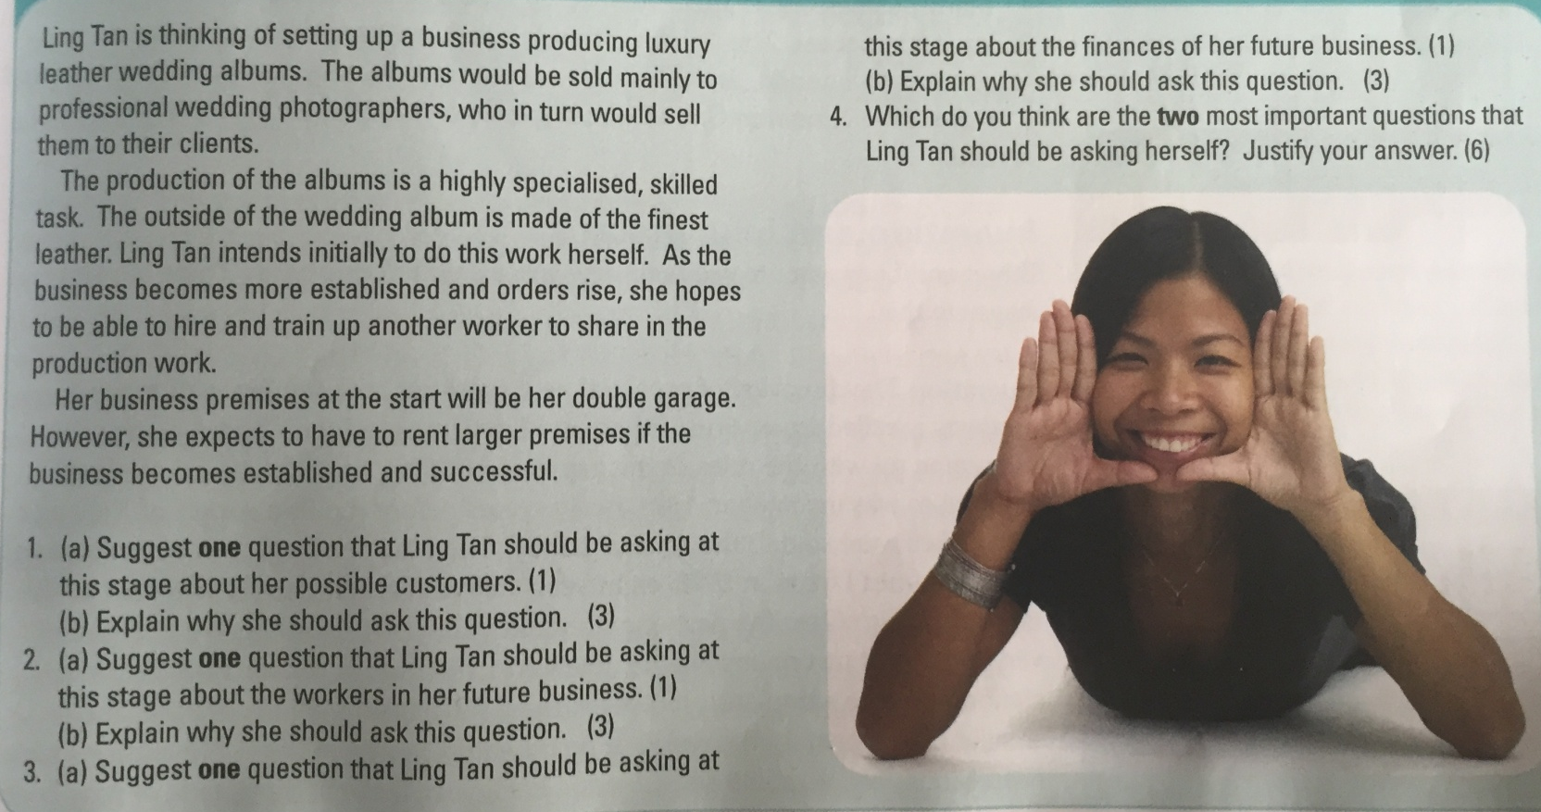
1(a)

1(b)

2(a)

2(b)

3(a)

3(b)

4.
Point 1:

Evidence from case study:

Explanation:

Point 2:

Evidence from case study:

Explanation:

