How might the above innovations have helped the named business grow?
Lithium batteries
.................................................................................................................................................................................................
.................................................................................................................................................................................................
.................................................................................................................................................................................................
.................................................................................................................................................................................................
.................................................................................................................................................................................................
Heat resistant chocolate
.................................................................................................................................................................................................
.................................................................................................................................................................................................
.................................................................................................................................................................................................
.................................................................................................................................................................................................
.................................................................................................................................................................................................
Contactless payment
.................................................................................................................................................................................................
.................................................................................................................................................................................................
.................................................................................................................................................................................................
.................................................................................................................................................................................................
.................................................................................................................................................................................................
Hybrid cars
.................................................................................................................................................................................................
.................................................................................................................................................................................................
.................................................................................................................................................................................................
.................................................................................................................................................................................................
.................................................................................................................................................................................................
Chocolate packaging
.................................................................................................................................................................................................
.................................................................................................................................................................................................
.................................................................................................................................................................................................
.................................................................................................................................................................................................
.................................................................................................................................................................................................
Airplanes
.................................................................................................................................................................................................
.................................................................................................................................................................................................
.................................................................................................................................................................................................
.................................................................................................................................................................................................
.................................................................................................................................................................................................

Heart-shaped sausages are a hit with young shoppers
Yorkshire brand Heck has doubled turnover by launching weird and wonderful sausage-based products.
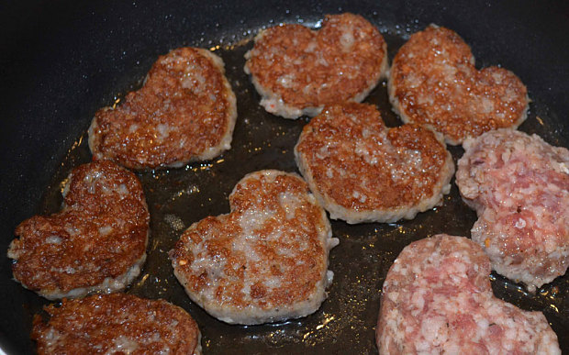
Sizzling sales of chicken sausages, heart-shaped bangers and square sausage meat burgers have driven up revenues at Yorkshire sausage brand Heck by 130%, as shoppers seek out quirky products and healthy-eating options.
The company is predicting revenues of £7m this year, up from £3m in 2013, an increase of 14% on their initial £6m turnover forecast.
According to co-founder Andrew Keeble, Heck has become popular with 18 to 35 year-olds because of its tongue-in cheek-branding and low-fat products. “These are health-conscious people who want a healthy alternative to regular sausages,” he said. “Our chicken sausage has become one of our bestselling lines.”
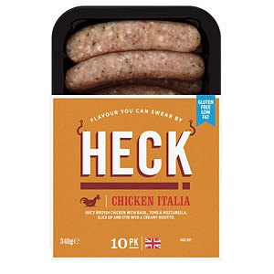
To capitalise on the popularity of leaner meat products, the company recently trialled a chicken burger in Tesco. “60% of the people that bought it hadn’t bought burgers in the last six months,” claimed Mr Keeble. “We’re bringing new customers into the category.”
Heck Sausages, which was founded by the family of pig farmers in 2012, only creates unusual sausage products, or quirky takes on traditional varieties, such as its chicken chipolatas and heart-shaped limited edition sausage for Valentine’s Day, which was called the “Peck”.
The company has created a square sausage, without a casing, that is among Heck’s bestsellers, alongside their take on a German Bratwurst, the Heck 97.
“We don’t do Cumberlands or Lincolnshires because we don’t want to compete with sausages that are already on the shelves,” explained Mr Keeble.
Some inventions have been too edgy for Heck’s supermarket customers. “We created a Guinness-flavoured sausage for St Patrick’s Day and called it 'Feck’,” said Mr Keeble. “No one was brave enough to list that so we’re going to make it available by mail order instead next time.”
Heck is investing £2m into a new factory near its north Yorkshire headquarters in order to try and keep growing. The company is also looking at launching a number of vegetarian products, Mr Keeble said. “It’s slightly away from our core base but the veggie shopper is an 18 to 45-year-old, affluent shopper, and that’s who we sell to,” he explained.
The brand became a household name after appearing on Alex Polizzi’s BBC Two programme The Fixer last year. The publicity not only opened doors at the supermarkets, it also led to a capital injection of £1m by private equity firm Panoramic Growth Equity. “6.5m people watched the programme and now we get stopped in the street,” said Mr Keeble.
Heck is the second sausage business from husband-and-wife team Andrew and Debbie Keeble. Their first brand, Debbie & Andrews, launched in 2003, is now the UK’s premium sausage brand. However, the Keebles lost control of the company when they sold it to a Dutch outfit in 2005.
Heck is one of the few remaining independent sausage brands in the UK. Rival company The Black Farmer is now part of listed company Cranswick, which sells its products under licence. “We’re not up for sale,” said Mr Keeble. “We want to stay a family business.”
Define organic growth. (2 marks)
.................................................................................................................................................................................................
.................................................................................................................................................................................................
.................................................................................................................................................................................................

Define innovation. (2 marks)
.................................................................................................................................................................................................
.................................................................................................................................................................................................
.................................................................................................................................................................................................

Identify 3 ways in which Heck has grown organically. (3 marks)
.................................................................................................................................................................................................
.................................................................................................................................................................................................
.................................................................................................................................................................................................

Why might Dyson find it easier to grow organically compared to Heck? (5 marks)
.................................................................................................................................................................................................
.................................................................................................................................................................................................
.................................................................................................................................................................................................
.................................................................................................................................................................................................
.................................................................................................................................................................................................
.................................................................................................................................................................................................
.................................................................................................................................................................................................
.................................................................................................................................................................................................
.................................................................................................................................................................................................

Choose 1 success and 1 failure and explain why you think they have succeeded/failed.
.................................................................................................................................................................................................
.................................................................................................................................................................................................
.................................................................................................................................................................................................
.................................................................................................................................................................................................
.................................................................................................................................................................................................
.................................................................................................................................................................................................
.................................................................................................................................................................................................
.................................................................................................................................................................................................
.................................................................................................................................................................................................

Please complete questions 3 and 5.
.................................................................................................................................................................................................
.................................................................................................................................................................................................
.................................................................................................................................................................................................
.................................................................................................................................................................................................
.................................................................................................................................................................................................
.................................................................................................................................................................................................
.................................................................................................................................................................................................
.................................................................................................................................................................................................
.................................................................................................................................................................................................
.................................................................................................................................................................................................
.................................................................................................................................................................................................
.................................................................................................................................................................................................
.................................................................................................................................................................................................
.................................................................................................................................................................................................
.................................................................................................................................................................................................
.................................................................................................................................................................................................
.................................................................................................................................................................................................
.................................................................................................................................................................................................
.................................................................................................................................................................................................
.................................................................................................................................................................................................
.................................................................................................................................................................................................
.................................................................................................................................................................................................
.................................................................................................................................................................................................
.................................................................................................................................................................................................
.................................................................................................................................................................................................
.................................................................................................................................................................................................
.................................................................................................................................................................................................
.................................................................................................................................................................................................
.................................................................................................................................................................................................

