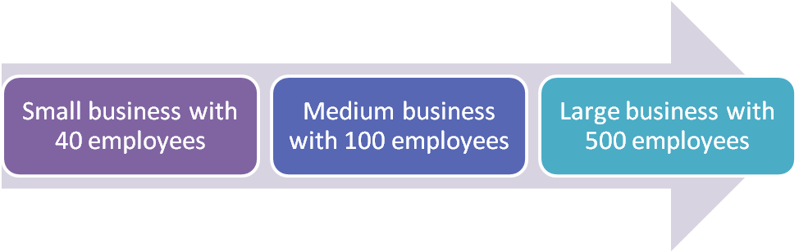

As a business grows, its organisational structure would change with it.
Discuss how the growth would affect:
- How knowledge and information is shared
- The organisational structure
- The types of change the business might face
- The resistance to change that might occur

