Case study: Bright’s Brewery
Bright’sBrewery Ltd is a growing medium-sized business located in Gosport. Although the brewery market is competitive, over the past four years it has seen its sales rise by 140 per cent and research suggests this large rise will continue. The company has just increased its capacity by opening a new factory where they have four flow production lines to make their locally produced bitters. However, over recent months Bright’s Brewery has faced problems, including cash-flow shortages, due to the amount tied up in stock. They have been with their suppliers for eight years and buy their stock in bulk so they can receive discounts and achieve economies of scale. Labour turnover is also increasing due to a large number of staff departing the company as they are de-motivated in their positions. Many feel that their ideas are not listened to and their jobs are repetitive and boring. The company’s operations manager Denzel is keen to use techniques of lean production and believes it will be of great benefit to the business. In order to remain competitive Bright’s Brewery is keen to improve the quality of its products and thinks lean production will play an important role in this.
Task 1
Use the diagram below to make notes on lean production.

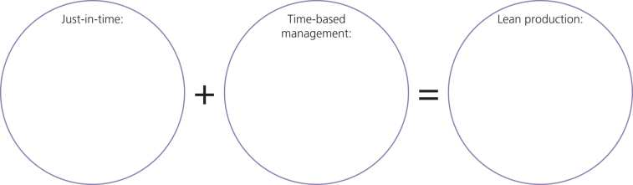
Task 2
Complete the table below to show the advantages and disadvantages of lean production.
Advantages | Disadvantages
More motivated workforce. This is because…
 | It may increase costs. This is because…
Task 3
Using the writing frames below, analyse two ways that implementing lean production would benefit Bright’s Brewery Ltd.
Point

Example
Explain

Point

Example
Explain

Task 4
- What is meant by the term ‘lean production’? (2 marks)

- What is meant by the term ‘just-in-time production’? (2 marks)

- You are a shareholder of Bright’s Brewery and opposed to them implementing lean production. Write a report to Denzel, the operations manager, explaining the reasons why you think that lean production is too risky and should not be implemented by Bright’s Brewery. (9 marks)

The main methods of lean production are summarised below:
Cell production
In traditional production, products were manufactured in separate areas (each with a responsibility for a different part of the manufacturing process) and many workers would work on their own, as on a production line. In cell production, workers are organised into multi-skilled teams. Each team is responsible for a particular part of the production process including quality control and health and safety. Each cell is made up of several teams who deliver finished items on to the next cell in the production process.
Cell production can lead to efficiency improvements due to increased motivation (team spirit and added responsibility given to cells) and workers sharing their skills and expertise.
Kaizen
Kaizen is a Japanese word for an approach to work where workers are told they have two jobs to do:
Firstly to carry out their existing task; and
Secondly to come up with ways of improving the task
The concept known as "continuous improvement" therefore implies a process where the overall progress and gains in productivity within a firm, come from small improvements by workers being made all the time.
For example, an employee may simply re-organise the lay out of his work area, which saves 2 minutes looking for and filing paperwork each day. When added up the course of a week, 10 minutes extra productive time is gained, which over a year equates to an extra days work. If other workers also adopt this, then a firm can benefit from a significant increase in output per worker (productivity) over a year.
Just in time
JIT means that stock arrives on the production line just as it is needed. This minimises the amount of stock that has to be stored (reducing storage costs).
JIT has many benefits and may appear an obvious way to organizes production but it is a complicated process which requires efficient handling. For example, JIT relies on sophisticated computer systems to ensure that the quantities of stock ordered and delivered are correct. This process needs to be carried out very accurately or production could come to a standstill.

