Models of Change Management

Lewin's Force Field Model

Change management is an important aspect of management that tries to ensure that a business responds to the environment in which it operates.
Remember that:
- Change is the result of dissatisfaction with present strategies (performance, failure to meet objectives etc)
- Change doesn't happen by itself - it is essential to develop a vision for a better alternative
- Management have to develop strategies to implement change
- There will be resistance to change - it is inevitable, but not impossible to overcome
Many factors drive change in a business. In his model Lewin identified four forces which are described below.

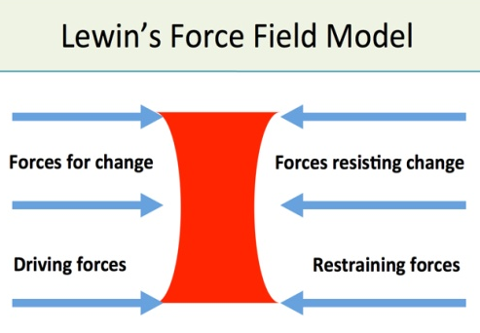
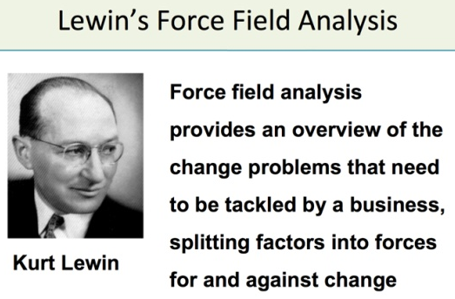

In Lewin's model there are forces driving change and forces restraining it. Where there is equilibrium between the two sets of forces there will be no change. In order for change to occur the driving force must exceed the restraining force.

Lewin's analysis can be used to:
- Investigate the balance of power involved in an issue
- Identify the key stakeholders on the issue
- Identify opponents and allies
- Identify how to influence the target groups
Forces for change include:
Internal forces for change (from within the business or organisation)
- A general sense that the business could "do better"
- Desire to increase profitability and other performance measures
- The need to reorganise to increase efficiency and competitiveness
- Natural ageing and decline in a business (e.g. machinery, products)
- Conflict between departments
- The need for greater flexibility in organisational structures
- Concerns about ineffective communication, de-motivation or poor business relationships
External forces for change (outside the control of the business / organisation)
There are many of these, including
- Increased demands for higher quality and levels of customer service
- Uncertain economic conditions
- Greater competition
- Higher cost of inputs
- Legislation & taxes
- Political interests
- Ethics & social values
- Technological change
- Globalisation
- Scarcity of natural resources
- Changing nature and composition of the workforce
You might conclude from the list of internal and external factors above that the main pressure for change in a business is usually external. A business has to be prepared to face the demands of a changing external environment.

Restraining forces (making change harder)
Despite the potential positive outcomes, change is nearly always resisted. A degree of resistance is normal since change is disruptive, and stressful
Some common reasons why change is resisted include:

Parochial self interest
Individuals are concerned with the implications for themselves; their view is often biased by their perception of a particular situation

Habit
- Habit provides both comfort and security
- Habits are often well-established and difficult to change
Misunderstanding of the need for or purpose of change
- Communications problems
- Inadequate information
Low tolerance of change
- Sense of insecurity
Different assessment of the situation
- Disagreement over the need for change
- Disagreement over the advantages and disadvantages
Economic implications
- Employees are likely to resist change which is perceived as affecting their pay or other rewards
- Established patterns of working and reward create a vested interest in maintaining the status quo
Fear of the unknown
- Proposed changes which confront people tend to generate fear and anxiety
- Introducing new technology or working practices creates uncertainty
Many of the potential restraining forces listed above are personal to an organisation's employees. There may also be overall organisational barriers to change, including:

- Structural inertia
- Existing power structures
- Resistance from work groups
- Failure of previous change initiatives

Change can also resisted because of the poor way in which change is managed! For example, a failure by management responsible for the change to:

- Explain the need for change
- Provide information
- Consult, negotiate and offer support and training Involve people in the process
- Build trust and sense of security
- Build employee relations

As a result of change resistance and poorly managed change projects, many of them ultimately fail to achieve their objectives. Amongst the reasons commonly associated with failed change programmes are:

- Employees do not understand the purpose or even the need for change
- Lack of planning and preparation
- Poor communication
- Employees lack the necessary skills and/ or there is insufficient training and development offered
- Lack of necessary resources Inadequate/inappropriate rewards

