Market Segmentation
(Hint: For the 3 mark questions, you will need to use the P/E/E structure)
1. How might Nando’s target different religious groups within its London restaurants? (3 marks)

2. How might a company that builds accommodation, target different groups of people who live in the south of England? (3 marks)

3. How might Mercedes target groups of people at the higher and lower ends of the socio-economic scale? (3 marks)

4. How can a business segment its market?

5. Why might a business use a market map? (3 marks)

6. What is a gap in the market and why is it important to identify one? (3 marks)

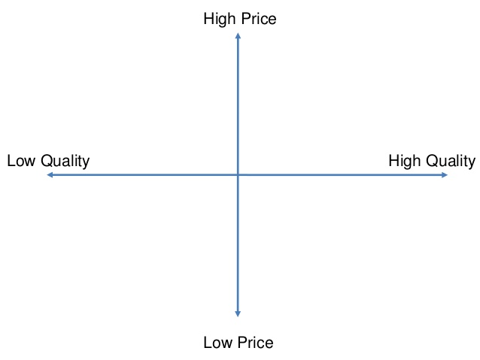
7. Please fill in the market map with the following chocolates: Galaxy, Ferrero Rocher, Cadbury’s Dairy Milk, Toblerone, Aero, Tesco own brand chocolate, Kit Kat:

8. S+C: Please identify where there is a gap in the market in the chocolate market. How could a new business take advantage of this gap? (6 marks)

