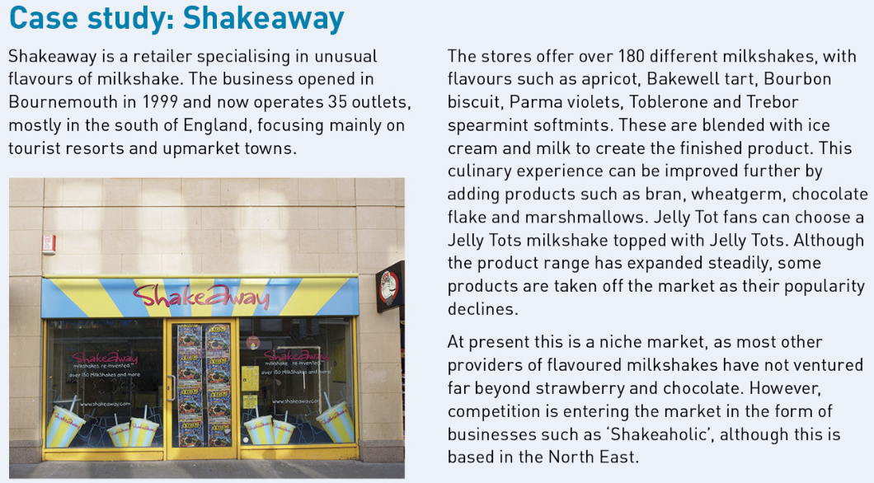
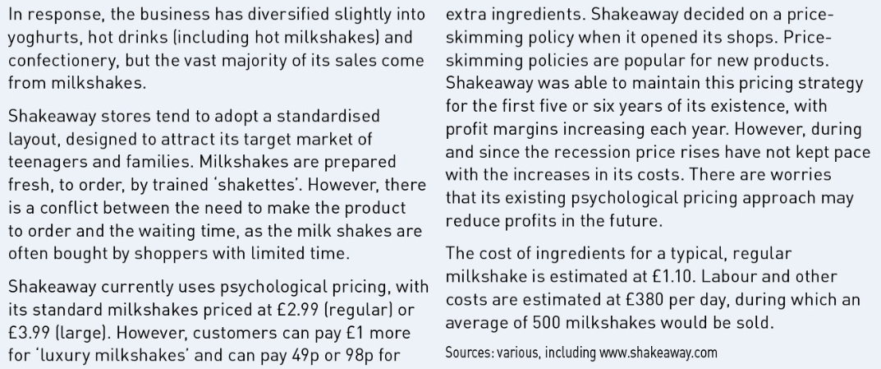
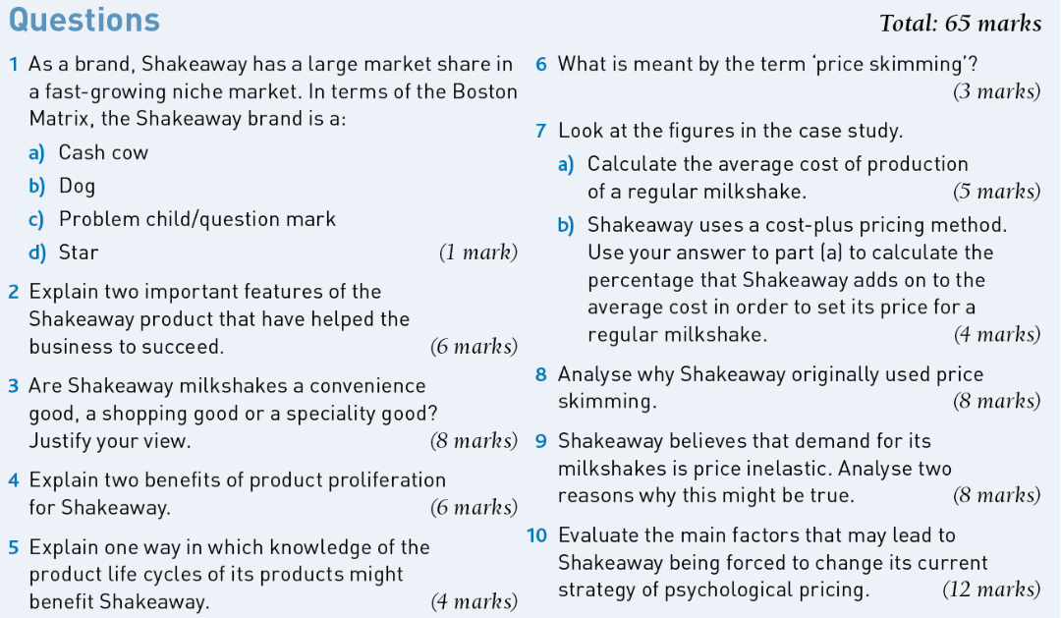
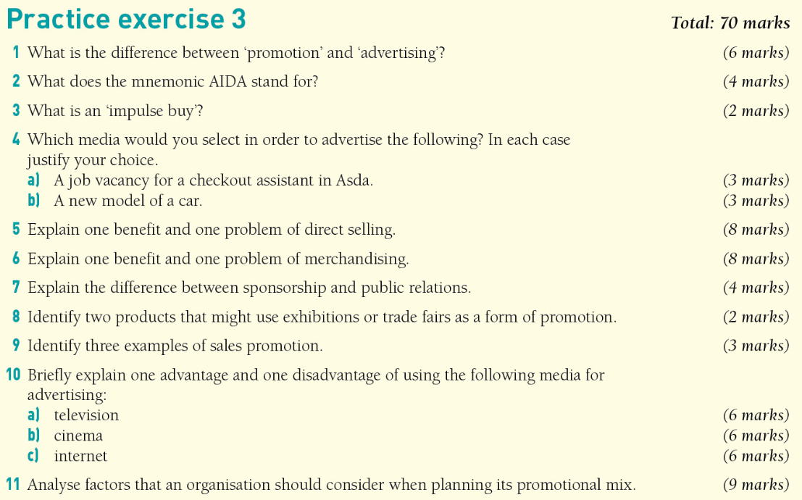

Analyse 2 benefits of branding to a business. (12 marks)
…………………………………………………………………………………………………………………………………………………………………………………………
…………………………………………………………………………………………………………………………………………………………………………………………
…………………………………………………………………………………………………………………………………………………………………………………………
…………………………………………………………………………………………………………………………………………………………………………………………
…………………………………………………………………………………………………………………………………………………………………………………………
…………………………………………………………………………………………………………………………………………………………………………………………
…………………………………………………………………………………………………………………………………………………………………………………………
…………………………………………………………………………………………………………………………………………………………………………………………
…………………………………………………………………………………………………………………………………………………………………………………………
…………………………………………………………………………………………………………………………………………………………………………………………
…………………………………………………………………………………………………………………………………………………………………………………………
…………………………………………………………………………………………………………………………………………………………………………………………
…………………………………………………………………………………………………………………………………………………………………………………………
…………………………………………………………………………………………………………………………………………………………………………………………
…………………………………………………………………………………………………………………………………………………………………………………………
…………………………………………………………………………………………………………………………………………………………………………………………
…………………………………………………………………………………………………………………………………………………………………………………………
…………………………………………………………………………………………………………………………………………………………………………………………
…………………………………………………………………………………………………………………………………………………………………………………………
…………………………………………………………………………………………………………………………………………………………………………………………
…………………………………………………………………………………………………………………………………………………………………………………………
…………………………………………………………………………………………………………………………………………………………………………………………
…………………………………………………………………………………………………………………………………………………………………………………………
…………………………………………………………………………………………………………………………………………………………………………………………
…………………………………………………………………………………………………………………………………………………………………………………………
…………………………………………………………………………………………………………………………………………………………………………………………
…………………………………………………………………………………………………………………………………………………………………………………………
…………………………………………………………………………………………………………………………………………………………………………………………
…………………………………………………………………………………………………………………………………………………………………………………………
…………………………………………………………………………………………………………………………………………………………………………………………
…………………………………………………………………………………………………………………………………………………………………………………………
…………………………………………………………………………………………………………………………………………………………………………………………
…………………………………………………………………………………………………………………………………………………………………………………………
…………………………………………………………………………………………………………………………………………………………………………………………

