Name:

What do you think the price of this product is? Why do you think it is this price?

Where would you see this product advertised? There maybe one than one place.

Where would you be able to buy this product? There maybe more than one place,

What is the product? Who is this product aimed towards?

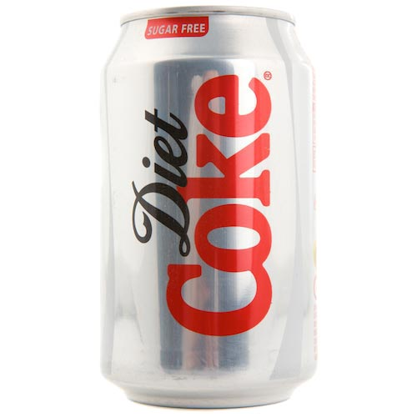

How would you improve their marketing? Should they advertise or sell their product in new places?

Who do you think the main competition for this product is? Try and give more than one.