My own business idea

The name of my business is: ......................................................

My business will sell: ......................................................

I came up with this idea because: ......................................................

Where will I sell my product and why?  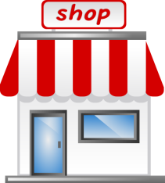 | What does my product do and why does it do this?  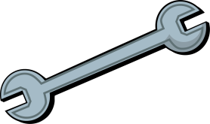
How much will I sell my product for and why?  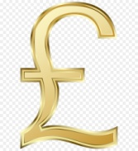 | How will I get people to buy my product?  