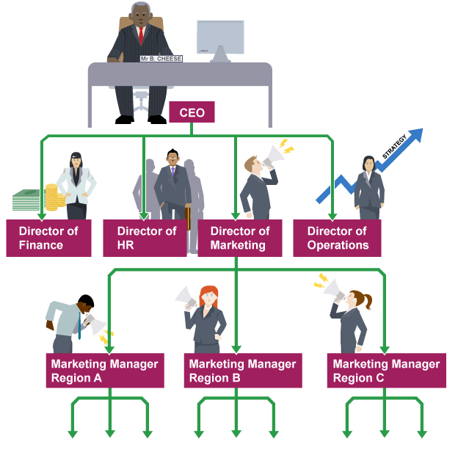
As a business grows in size and takes on more staff, managers need to make sure employees understand their role within the company. Organisation is the way a business is structured.
One method of organisation is to set up departments covering the four main areas of business activity:
- finance
- human resources
- marketing
- operations
Organisation charts are diagrams that show the internal structure of the business. They make it easy to identify the specific roles and responsibilities of staff. They also show how different roles relate to one another and the structure of departments within the whole company.
For example, the Marketing Manager in the Midlands can see at a glance that she is in charge of ten subordinates, and that her line manager is the Director of Marketing.

- Hierarchy refers to the management levels within an organisation.
- Line managers are responsible for overseeing the work of other staff.
- Subordinates report to other staff higher up the hierarchy. Subordinates are accountable to their line manager for their actions.
- Authority refers to the power managers have to direct subordinates and make decisions.
- Delegation is when managers entrust tasks or decisions to subordinates.
- Empowerment sees managers passing authority to make decisions down to subordinates. Empowerment can be motivational.
- The span of control measures the number of subordinates reporting directly to a manager.
- The chain of command is the path of authority along which instructions are passed, from the CEO downwards.
- Lines of communication are the routes messages travel along.
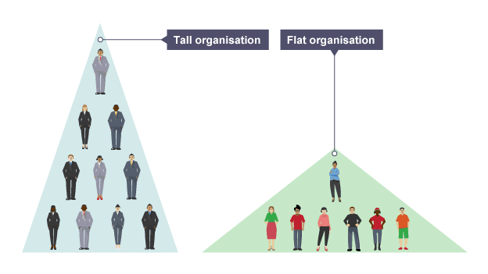

Tall organisations have many levels of hierarchy. The span of control is narrow and there are opportunities for promotion. Lines of communication are long, making the firm unresponsive to change.
Flat organisations have few levels of hierarchy. Lines of communication are short, making the firm responsive to change. A wide span of control means that tasks must be delegated and managers can feel overstretched.
In centralised organisations, the majority of decisions are taken by senior managers and then passed down the organisational hierarchy.
Decentralised organisations delegate authority down the chain of command, thus reducing the speed of decision making.

One method of reducing costs is to remove a layer of management in a hierarchy while expecting staff to produce the same level of output. This is called delayering.

Centralised and Decentralised Businesses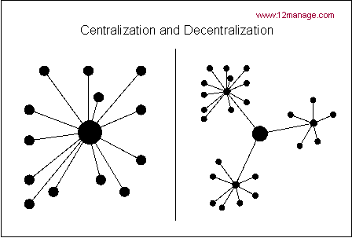
What are the advantages and disadvantages of Decentralised businesses?

Mark ADVANTAGES with an A and DISADVANTAGES with D

Senior management free to concentrate on strategy | Promotion opportunities
Inconsistency with decisions across the company | Branch managers empowered
Same roles are duplicated | More information needed
Local expertise of market | Quick responses – smaller chain of command

Key Term: | Definition:
Delayering | Removing layers of management and workers in a hierarchy so that there are fewer workers in the chain of command.
Empowerment | Giving more responsibility to workers further down the chain of command in the hierarchy.
Downsizing | When a business employs fewer workers to produce the same amount through increases in productivity which can be achieved through delayering.
Delegation | Passing down of authority for work to another worker further down the hierarchy of the organisation.
Centralisation | A type of business organisation where decisions are made at the centre or core of the organisation and then passed down the chain of command.
Decentralisation | A type of business organisation where decision making is pushed down the hierarchy and away from the centre of the organisation.

Using the example of The Compton School, what does it mean by the terms:

  - Delayering

  - Empowerment

  - Downsizing

  - Delegation

  - Centralisation

  - Decentralisation
Give 4 disadvantages of a long chain of command:

What is the benefit of empowering employees?

Create 2 mind maps, one showing the advantages and disadvantages of a centralised business, and the other for a decentralised business.

