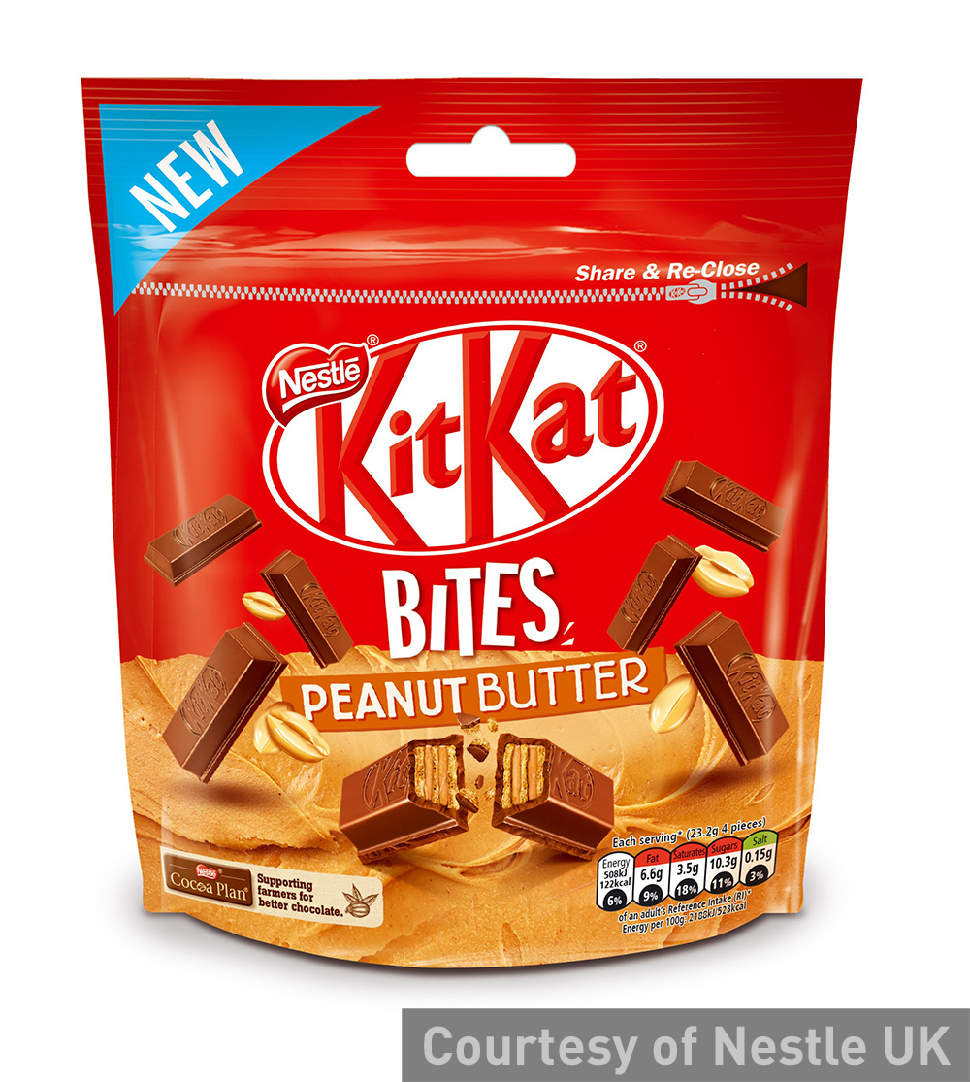
3. Explain the purpose of Nestle launching this new Kit Kat product. (6 marks)
New Kit Kat lines launched
Nestlé Confectionery is adding to the shopper appeal of Kit Kat – the fourth-ranked impulse chocolate brand – with a new sharing product that will be available from 14 September.
Kit Kat Bites, a 104g bag containing mini-chocolate fingers, has an recommended retail price of £1.59 and is designed to capitalise on the growing popularity of shared occasions with friends and family and will benefit from a £4m ad campaign.
It follows last month’s arrival of Kit Kat Chunky Cookie Dough (RRP 60p), which combines chunky chocolate with cookie dough.
Source: www.talkingretail.com, September 2016

4. What others extension strategies might Nestle have considered? (6 marks)

