3.4 Using the marketing mix
Product life cycle: Activity
Task 1: Product life cycle
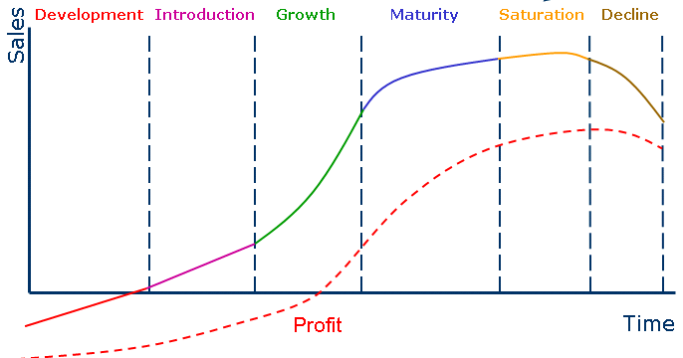
Explain each stage of the life cycle. Ensure you discuss the level of revenue, the amount of costs, profit, amount of promotion required and level of competition. For each stage think of some real product examples that you feel are at this stage in their life cycle.

Task 2: Extension strategies
Mind map as many different extension strategies as you can think of that a business could use to avoid decline. Provide real examples of firms for each strategy.

