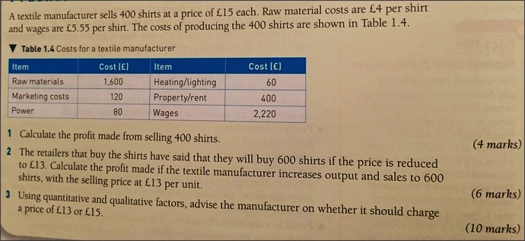
(16 marks for question 3)

1.

2.

3. They should sell at £13 because:

The case study states:

This is important because:

This would mean that:

This would lead to:

Therefore, meaning:

However:

They should sell at £15 because:

The case study states:

This is important because:

This would mean that:

This would lead to:

Therefore, meaning:

However:

Considering:

I believe the best option is:

It’s a better option because:

However, to what extent this decision is valid depends upon:

