Invention and Innovation

The UK Government website tells us about intellectual property.

Intellectual property is something unique that you physically create. An idea alone is not intellectual property. For example, an idea for a book doesn’t count, but the words you’ve written do.
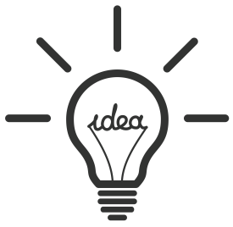
- Why do you think it’s important for businesses to protect their ideas?

Please use the following terms in your answers:

Business Unique Invention Innovation Idea USP Protect Profit Competitor Steal

What intellectual property is:
Having the right type of intellectual property protection helps you to stop people stealing or copying:
- the names of your products or brands
- your inventions
- the design or look of your products
- things you write, make or produce

Examples of Intellectual Right:
Wikipedia® | Is a registered trademark of the Wikimedia Foundation, Inc., a non-profit organisation.
© Joanne Rowling 1999” | “Copyright Is Printed in JK Rowling’s ‘Harry Potter and the Prisoner of Azkaban’.
GB 2439518 | A UK patent application number in 2008.

- Indicate whether the following are patents, copyrights or trademarks

Variable | Patent | Copyright | Trademark
The ‘McDonalds’ company name.
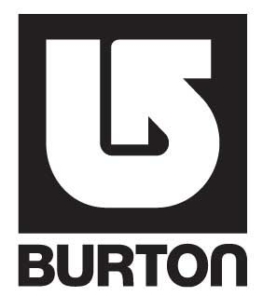
The ‘Google’ company name.
J.K. Rowling – ‘Harry Potter and the Deathly Hallows.
The manufacturing process of making ‘The Sun’ newspapers.
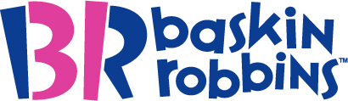
The technologies used to develop the Apple iPhone 4S.
‘The Dark Night Rises’ film
The ‘Xbox’ product name.
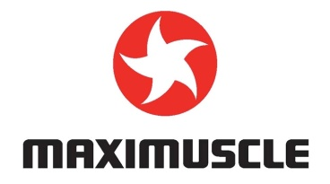
The ‘Samsung’ company name.
A Rolex watch.
- Please fill in the gaps using the words below (Hint, not all are used, and they are only used once)

Patents:
Inventors can gain protection through patents. Anyone .................... a patented idea can be taken to court
and sued for damages. In the UK, patents are given for twenty years. Patents must be registered with the
.................... Office. Patents can also be registered internationally although this is expensive. Patents are given
for products or production processes. Patents last 20 years from when they are first ....................

Copyright:
This is given for intellectual property rights such as ...................., music and .................... Copyright gives the
.................... to produce, control and copy the work solely to the individual or the company that produced the
work. If others copy such material they can also be taken to .................... Copyright protection lasts longer
than patents. Authors of books, for example, have copyright over the book during their lifetime and for 70
years after they are dead.

Trademarks:
A trademark is a name of a .................... or a business that cannot be copied. For example, the name ‘Coca-
Cola’ is a registered .................... Coca-Cola can sue any business which tries to sell any product under the
Coca-Cola name.
trademark patent film copying right created
books product court granted intellectual property

Application to a business
- Using the information you have just filled in, please answer the following questions:

Where must a business go to, to register a patent or copyright? (2 marks)

........................................................................................................................................................................

........................................................................................................................................................................

Give 2 disadvantages of a patent and explain why they are disadvantages. (4 marks) (P/E)

........................................................................................................................................................................

........................................................................................................................................................................

........................................................................................................................................................................

........................................................................................................................................................................

........................................................................................................................................................................

........................................................................................................................................................................

Why might a copyright offer more protection than a patent? (3 marks) (P/E/E)

........................................................................................................................................................................

........................................................................................................................................................................

........................................................................................................................................................................

........................................................................................................................................................................

S+C evaluation question: What is the advantage to a business of having a trademark? What might it allow them to do? (Think about consumers’ thoughts of your business) (3 marks)

........................................................................................................................................................................

........................................................................................................................................................................

........................................................................................................................................................................

........................................................................................................................................................................

Extension:
Think about your own business idea and how you might need to protect it.
What’s your business idea?

Do you have a brand name or slogan? What is it?

What protection might you need for your product?

Explain the advantages of this protection.

Explain the disadvantages of this protection.

