4.4 Improving quality
Improving quality: Activity
Case study: Quality problems at Unique Electronics (UE) facing sales decline and possible job cuts
Unique Electronics (UE) is a modern electronics firm which specialises in laptops, mobile phones and MP3 players. When UE's first few lines started rolling out initial customer and industry reports seemed almost too good to be true. Sales were high and customer reviews favourable. UE built up a strong brand image with its fashionable modern electronic products revolutionising the way people handled and used, files, music and video.
All of that began to change after units started shipping in larger quantities. No computer and electronics firm produces flawless products, but UE had built a reputation for being a cut above most of its rivals. Its MP3 players began to receive complaints about screens cracking and batteries failing. Accusations were made that the products had been rushed out to increase profits and some consumers were taking UE to court over this. Customers had also begun to complain about the laptops. They were ‘whining’, overheating and even causing small fires. Some believed UE had been using cheaper raw materials; others believed that they had not been controlling their quality and were growing as a business too quickly, losing their focus on what had made them successful in the first place: high quality innovative products.
Internal management reports were claiming there were big problems at the production plants. Standards had slipped. The factories were working at full capacity to manage the increased output. Workers had been encouraged to maximise productivity and output and had been offered piece rate pay to maximise output. There were also reports of unhappy workers and potential trade union action due to the stressful workplace, unpleasant working conditions and neglect of workers. One was quoted as saying; ‘All they expect is output. We are treated like robots. We get the minimum breaks and no training to help career progression or improve our work. Plenty of people have begun leaving and taking their valuable skills away from the company. It won’t be long before consumers take their custom elsewhere.’

 | 2009 | 2014
Labour turnover | 2% | 10%
Absenteeism | 1.5% | 1.6%
Customer complaints | 2,500 | 18,256
Product recalls | 3,560 | 20,000
Output | 450,000 | 1,000,000
Number of workers | 440 | 1,156
Capacity utilisation | 89% | 98.9%

Tasks
- In pairs identify at least nine potential reasons why Unique Electronics (UE) may be suffering quality problems.
Causes of quality problems at Unique Electronics
1.
2.
3.
4.
5.
6.
7.
8.
9.

- Put each of the causes of poor quality into the box according to how significant they were in the firm’s negative customer image and complaint levels. Ensure you can justify your decisions based on data from the case study.

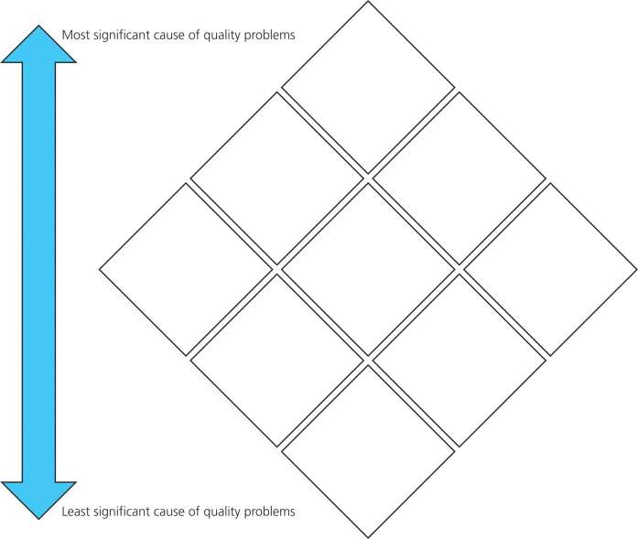
- Proposals for improving Unique Electronics quality problems identified previously:

Proposals for solving problems | Benefits of proposal | Drawbacks of proposal
1.
2.
3.
4.

Below, create a plan for the following question. Evaluate whether using a quality control system or quality assurance system would be more beneficial to UE. (16 marks)

Evidence to support quality control.
1.

Explanation of why this supports your point.

2.

Explanation of why this supports your point.

Evidence to support quality assurance.
1.

Explanation of why this supports your point.

2.

Explanation of why this supports your point.

Evaluation.

What is a big problem facing this business?

Based on this, what do you think the best quality system is?

Why is this a better option?

To what extent is this decision valid?

