Putting a business idea into practice

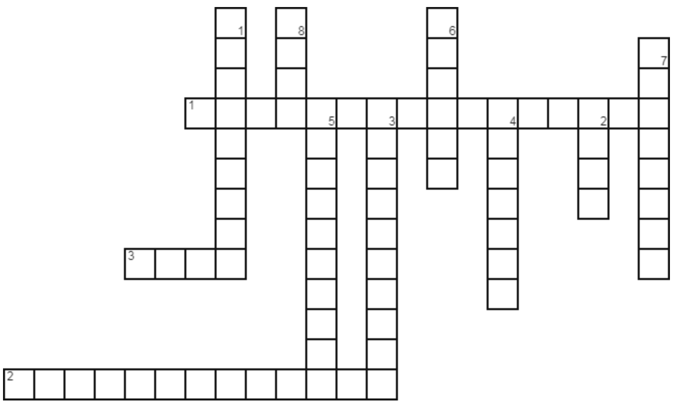

Extension

Select the correct name for each of the following calculations:

Your sales as a % of total sales in a market

Selling price x quantity

Fixed costs + variable costs

Total revenue – total costs

A % added on to an initial amount borrowed

Selling price – variable cost per unit

Fixed costs/contribution

Actual output – Break even output

Total inflows – total outflows

Net cash flow + opening balance

Last month’s closing balance

Contribution
Closing balance
Net cash flow
Market share
Revenue
Total costs
Opening balance
Break-even point
Margin of safety
Profit/loss
Interest

Super Extension

Business A sells its products for £2.50. Over the last year it has sold 150,000 products, which each cost 85p to make. The business has fixed costs of £200,000.

Business B sells its products for £300. Over the last year it has sold 20,000 products, which each cost £190 to make. The business has fixed costs of £2,500,000.

1) Which business is more profitable?

2) What is the break-even point for each business?

3) Give two ways in which a business can become more profitable.

