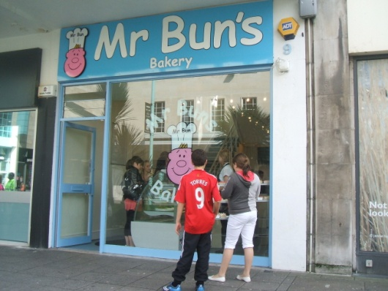

*Recommendations:*



*Case Study One*

Company Name: Aerosaurus Balloons

Business Need:

The business takes a lot of bookings from local people, but they’d like to reach more customers without having to take on a lot of new sales staff. They also need a cheaper way of sending out booking confirmations than sending detailed paperwork by post.



*Case Study One*

Company Name: Aerosaurus Balloons

Business Need:

The business takes a lot of bookings from local people, but they’d like to reach more customers without having to take on a lot of new sales staff. They also need a cheaper way of sending out booking confirmations than sending detailed paperwork by post.

Company Name: Mr Buns

Business Need:

Mr Buns opened near the shopping mall and business has rocketed. The manager needs some method of increasing production of the buns and cakes to keep up with demand. The cakes are very high quality and must be finished by hand.

*Case Study Two*

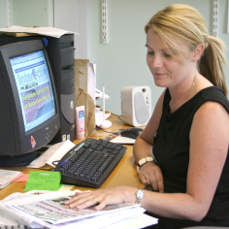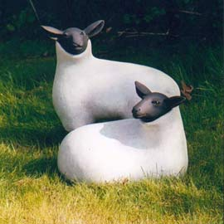

*Recommendations:*

*Recommendations:*

*Case Study Three*

Company Name: Orchard Pottery

Business Need:

Sales of handmade garden wares have increased, but the owners aren’t sure exactly how these sales compare with last year. As they now receive a lot of online sales, they want to be able to see what needs making ahead of time so they don’t get behind.

*Recommendations:*

*Recommendations:*



*Case Study Four*

Company Name: Evening Herald

Business Need:

Helen wants to work from home and send articles into work quickly and securely. The company still need to be able to get hold of her during work hours and also want to find a way for her to be able to participate in meetings and decision making.