The Business Cycle
- In the spaces on graph label the different stages of the economy using the words provided

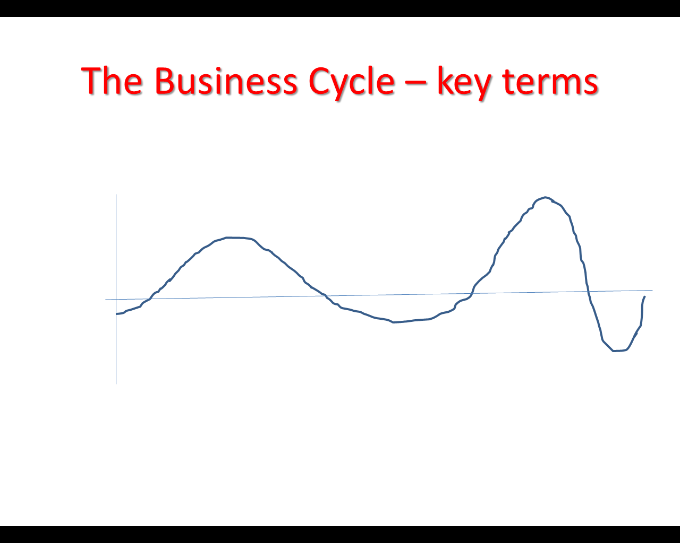
GDP RECESSION GROWTH BOOM SLUMP TIME RECOVERY

- In the spaces provided draw an upward or downward arrow to show what will happen to different parts of the economy
