The Role of Entrepreneurship

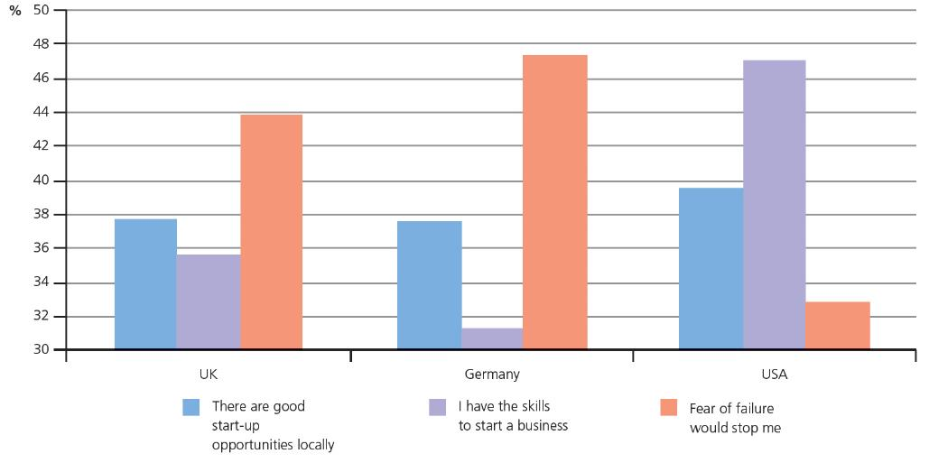

Compare the countries on the bar chart. Explain two conclusions that you can draw from this information:

1.

2.

Extension – Can you name an entrepreneur from each country and their business?

UK:

Germany:

USA:

Watch the Starbucks video:

Was Starbucks hiring 10,000 military veterans a good business decision and why?

Hint: Think about the skills soldiers have, the brand image it creates and why the US government would be happy with this decision.

1.

2.

3.

Extension – Can you think of any disadvantages Starbucks might face from this decision?

Look at the key skills it takes to be a good leader:

1. Communication
2. Motivation
3. Delegating
4. Positivity
5. Trustworthiness
6. Creativity
7. Feedback
8. Responsibility
9. Commitment
10. Flexibility

Take 2 of these skills and explain why they are so important.

1.

2.

Extension – Jeff Bezos is the CEO of Amazon. Explain where he has shown creativity and why this has led to the success of his business.

1.

2.

3. They should build the BBQ area.

Evidence to support this:

This is important because:

They should open the city centre kiosks.

Evidence to support this:

This is important because:

I believe the best option is and why:

This is better than the other option because:

However, to what extent this decision is valid depends upon:

