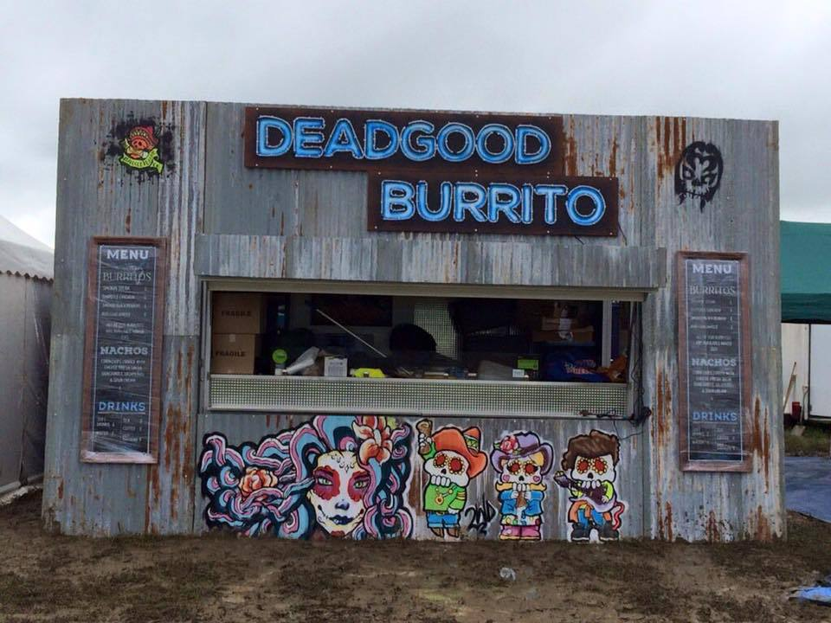
1. Explain the importance for a business like “Deadgood Burrito” in maintaining a strong social media presence. (6 marks)
Deadgood Burrito Company
The Deadgood Burrito Company is a Mexican Street food business that is based in Brighton. Its target market consists of those attending street food festivals as well as the summer music festival scene. During 2016 Deadgood Burrito pitched up at festivals such as Bestival in Lulworth and Glastonbury. In addition, the business also attends the weekly student food
market at Sussex University and it attends numerous outdoor events around the country.
Deadgood Burrito maintains a website and also has a significant presence on social media – including Facebook and Twitter.
Source: www.deadgoodburrito.com

2. How important is the concept of place to “Deadgood Burrito”? (6 marks)

3. The owners of “Deadgood Burrito” are considering two options in order to grow sales.
Option 1: Lease a small shop in Brighton
Option 2: Purchase another mobile kitchen to expand its coverage of festivals
Which of these two should it consider investing in? (9 marks)

