Edexcel GCSE- Business (9-1) worksheet
    - Why new business ideas come about
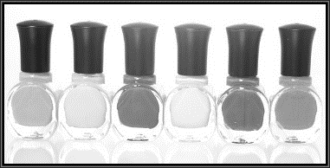
What is a product?
___________________________________________________________________________________________________________________________________________________________________________________________________________________________________________________

What is a service?
___________________________________________________________________________________________________________________________________________________________________________________________________________________________________________________

What changes in technology have created new products and services?
___________________________________________________________________________________________________________________________________________________________________________________________________________________________________________________

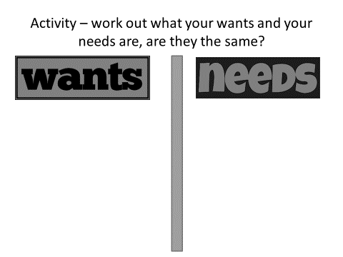

What changes have there been in consumer wants?
___________________________________________________________________________________________________________________________________________________________________________________________________________________________________________________
What does obsolete mean?
___________________________________________________________________________________________________________________________________________________________________________________________________________________________________________________

List obsolete products here:
1
2
3
4
5

