Communication

Explain the difference between internal and external communication.

Give 3 examples of each:

Internal

External

Explain the difference between formal and informal channels of communication.

Explain the difference between horizontal and vertical communication.

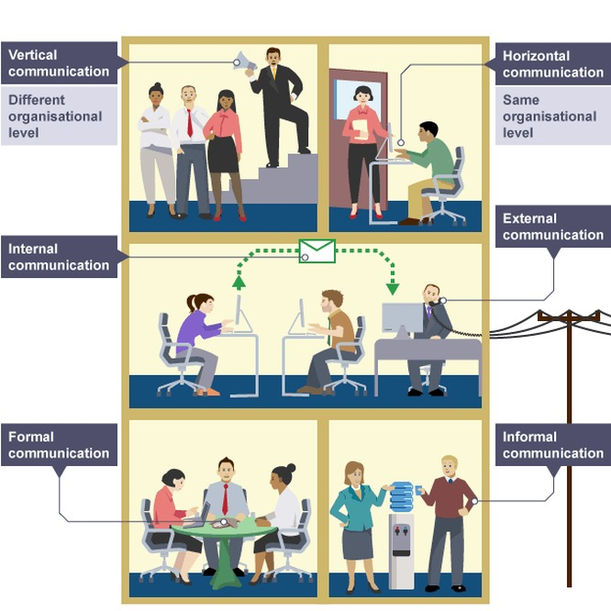

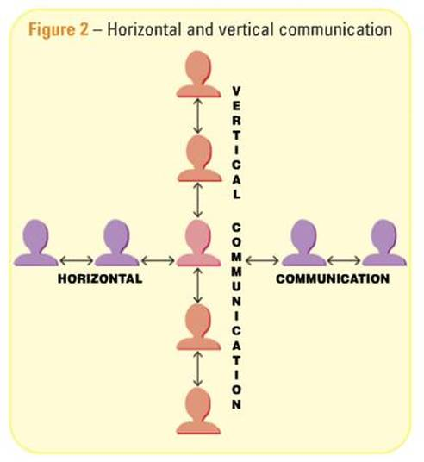

What potential problems could informal communication cause within a business? Give an example.

State and explain 4 factors that lead to effective communication.

1.

2.

3.

4.

State and explain 5 barriers to communication.

1.

2.

3.

4.

5.

Give 3 advantages of good communication

Give 3 disadvantages of poor communication

This worksheet displays four different scenarios involving various types of communication used by business organisations. For each scenario you need to indicate the following in the right hand box:
- The communication process
- Horizontal or vertical communication
- Internal or external communication
- Formal or informal communication
- The barriers to communication
- Alternative actions
Scenario 1:
“Ashwin is the owner and one of three dentists that work at his surgery in Kingsbury. One morning he felt unwell and emailed his receptionist that he would be unable to come into the surgery for that day. However, the receptionist did not check her emails until mid-morning, resulting in several of Ashwin’s customers arriving to the surgery uninformed that he could not fulfil their appointments. The receptionist replied to Ashwin’s email to let him know she had received the message and will contact his customers for the rest of the day.”
The Communication Process: | Sender:  Communication:  Receiver:  Feedback:
Horizontal or Vertical:
Internal or External:
Formal or Informal:
Barriers to Communication:
Alternative Actions:

Scenario 2:
“Juliette is the stage manager for a well known theatre company in London. One of her responsibilities is to ensure that the costumes and props are ready for the show beginning. Three weeks before the show started Juliette rung her suppliers to place an order for the products she required. They assured her that she would receive her order in 5 working days. After two weeks Juliette had not received her order so decided to ring her suppliers. They told her that no order had been received and that they would not be able to deliver her products in time for the show.”
The Communication Process: | Sender:  Communication:  Receiver:  Feedback:
Horizontal or Vertical:
Internal or External:
Formal or Informal:
Barriers to Communication:
Alternative Actions:

Scenario 3:
“Kenneth is the owner of a small music shop in Wembley that sells a variety of instruments. He has stocked some new DJ equipment and created a poster to put up outside his shop. Since he put this poster up only a few customers enquired about the products. When they found out when talking to Kenneth in person how low his prices his sales went up twofold.”
The Communication Process: | Sender:  Communication:  Receiver:  Feedback:
Horizontal or Vertical:
Internal or External:
Formal or Informal:
Barriers to Communication:
Alternative Actions:

Scenario 4:
“Sachin is the manager of Powerleague in Alperton offering a range of 5-a-side facilities to the local community. The director of Powerleague gave Sachin a 100 page report giving a variety of new guidelines to implement to his store and asked for some feedback. Reading the report was very time consuming and contained a lot of irrelevant information. Sachin wrote a number of notes on the report and gave it back to the director.”
The Communication Process: | Sender:  Communication:  Receiver:  Feedback:
Horizontal or Vertical:
Internal or External:
Formal or Informal:
Barriers to Communication:
Alternative Actions:

